Petrography Report and Study of Samples
From the Eagle Prospect,
Keno Hill Silver District, Canada

Prepared by
Liana Stammers
Alexco Resource Corp.

April 24, 2017

Table of Contents

Table of Contents i
List of Figures ii
Introduction 1
Objective 1
Overview 1
Mineral Abbreviations 1
Paragenesis 1
Methods 3
Petrography Overview 5
References 10
Appendix I: Paragenesis 11
Appendix II: Petrographic Descriptions and Photos 14

List of Figures

Figure 1 : Hand sample photos of (A) banded mineralization of sphalerite, pyrite and chalcopyrite from D09EE07_210.5m, and (B) brittle brecciation of quartz, siderite and pyrite from D09EE11_254.15m. 5

Figure 2 : Photomicrographs in plane polarized light of sphalerite colour variation in (A) from blood red to orange near pyrite in D09EE07_210.50m, and (B) from red to orange near fractures in D09EE07_212.20m. 6

Figure 3 : Photomicrographs in reflected light of D09EE07_210.50m showing (A) chalcopyrite as small inclusions in sphalerite and (B) as discontinuous elongated strands parallel to flow banding. (B) also has associated tetrahedrite. Red scale bars are 500µm. 6

Figure 4 : Photomicrographs in reflected light from D09EE07_210.50m of (A) chalcopyrite stands in flow banding with sphalerite with pyrrhotite and associated pyrite. (B) is aligned grains of arsenopyrite with inclusions of pyrhhotite and chalcopyrite flecks in sphalerite. Red scale bar is 500µm. 7

Figure 5 : Photomicrographs in reflected light of pyrite in breccia matrix and fractures in (A) from D09EE07_212.2m and (B) from D09EE11_254.1m. Pyrite clusters aligned parallel to flow in (C) from D09EE07_213.35m and (D) from D09EE11_263.4m. Red scale bar is 500µm. 8

Figure 6 : Photomicrograph in reflected light of siderite cut by sphalerite. Needles and patches of boulangerite cut sphalerite and siderite. Late pyrite overprints all earlier mineralization. Red scale bar is 200µm. 9

List of Tables

Table 1: Samples taken for the Petrographic report with their respective holes, depths, multi-element geochemical analysis sample number and vein. 1
Table 2 : Mineral Abbrevations for Minerals observed or previously observed in Keno Hills mineralization based off Whitney and Evans (2010), and those accepted by the Geological Associated of Canada. 2
Table 3 : Other abbreviations used in the text and appendix. 3

Introduction

Objective
To identify mineral assemblages, paragenesis, and textures from drill core samples from the Eagle prospect.

Overview
This report contains a petrographic report on seven drill core samples taken from the Eagle Vein located in the Keno Hill Silver District. The samples were obtained from the Yukon Geological Survey core library located in Whitehorse from holes completed by Mega Precious Metals Inc. in 2009. A comprehensive list of samples with their respective vein, hole, sample, and depth is shown in Table 1.
Polished thin sections of the samples were observed on a OMAX Reflected and Transmitted Microscope and photographed with an OMAX camera attachment using ToupView between January and April 2017.

Table 1: Samples taken for the Petrographic report with their respective holes, depths, multi-element geochemical analysis sample number and vein.
Hole | Depth | Sample | Vein
D09EE07 | 210.5 | 75787 | Eagle
D09EE07 | 212.2 | 75791 | Eagle
D09EE07 | 213.35 | 75795 | Eagle
D09EE11 | 254.1 | 75937 | Eagle
D09EE11 | 254.15 | 75937 | Eagle
D09EE11 | 263.4 | 75949 | Eagle
D09EE11 | 264.5 | 75950 | Eagle

Mineral Abbreviations
Mineral abbreviates are derived from Whitney and Evans (2010), and those accepted by the Geological Associated of Canada. A list of minerals, their abbreviations, and their chemical composition is found in Table 2. Note that most sulphosalts beyond pyrargyrite are not distinguished within the petrography, as their optical properties are very similar and cannot be differentiated petrographically. These minerals are referred to as “sulphosalt” or “tetrahedrite” within the appendix, and the photomicrographs. Other abbreviations are in Table 3.

Paragenesis
Paragenesis within the petrography was compared to the Master’s study by Hantelmann (2013) completed on samples primarily from Alexco Resource Corp’s Bellekeno Mine. As mineral textures and composition vary between Bellekeno and other deposits in the Keno Hill District, stage numbers assigned to the different phases are best approximations and do not completely reflect the phases described by Hantelmann.
For the reader’s convenience, a summary has been taken from Hantelmann to describe the different stages and added in Appendix I.
Table 2 : Mineral Abbrevations for Minerals observed or previously observed in Keno Hills mineralization based off Whitney and Evans (2010), and those accepted by the Geological Associated of Canada.
Aca | acanthite | Ag2S
Ag | silver | Ag
Ang | anglesite | PbSO4
Ank | ankerite | (Ca,Mg_{,Fe})CO₃
Apy | arsenopyrite | FeAsS
Au | gold | Au
Boul | boulangerite | Pb5Sb4S11
Cal | calcite | CaCO3
Cpy | chalcopyrite | CuFeS2
Cer | cerussite | PbCO3
Cob | cobaltite | CoAsS
Cnf | canfieldite | Ag8SnS6
Cnt | cerianite | CeO2
Cst | cassiterite | SnO2
Dol | dolomite | CaMg(CO₃)₂
Fah | fahlore | (Cu,Ag)₁₀(Fe,Zn)₂(As,Sb)₄S₁₃
Frb | freibergite | Ag₆(Cu₄Fe₂)(Sb₄S_{13-X})
Ger | gersdorffite | NiAsS
Gn | galena | PbS
Goe | goethite | FeO – OH
Gr or C | graphite | C
Hem | hematite | Fe₂O₃
Jam | jamesonite | FePb₄Sb₆S₁₄
Kln | kaolinite | Al₂Si₂O₅(OH)₄
Kut | kutnohorite | Ca(Mn,Mg)(CO₃)₂
Mag | magnetite | Fe₃O₄
Mil | millerite | NiS
Mnz | monazite | (Ce,La,Y,Th)PO₄
Mrc | marcasite | FeS₂
Musc | muscovite
Phl | phlogopite | KMg₃Si₃AlO₁₀(F,OH)₂
Po | pyrrhotite | Fe_{1-x}S
Plb | polybasite | Cu(Cu,Ag)₆Ag₉Sb₂S₁₁
Prt | proustite | Ag₃AsS
Py | pyrite | FeS₂
Pyr | pyrargyrite | Ag₃SbS₃
Qtz | quartz | SiO₂
Rds | rhodochrosite | MnCO₃
Rt | rutile | TiO₂
Sd | siderite | (Fe, Mn)CO₃
Snn | stannite | Cu₂FeSnS₄
Sph | sphalerite | (Zn,Fe)S
Stb | stibnite | Sb₂S₃
Stn | stephanite | Ag₅SbS₄
Trs? | Treasurite | Ag₇Pb₆Bi₁₅S₃₂
Tnt | tennantite | Cu₆(Cu₄(Fe,Zn)₂)As₄S₁₃
Ttr | tetrahedrite | Cu₆(Cu₄(Fe,Zn)₂)Sb₄S₁₃
Ag-Ttr | argentotetrahedrite | Ag₁₀(Fe,Zn)₂Sb₄S₁₃
Tour | tourmaline
Zrn | zircon | ZrSiO₄

Table 3 : Other abbreviations used in the text and appendix.
Breccia | bx
Coarse grain | cg
Fault | flt
Fine grain | fg
Fractures | fract
Medium grain | mg
Very coarse grain | vcg
Very fine grain | vfg

Methods
The Eagle Vein samples were taken from drill core samples obtained from the Eagle property in 2009-2010 from work completed by Mega Precious Metals (Tupper, 2010). Samples were obtained from the H.S. Bostock Core Library in Whitehorse maintained by the Yukon Geological Survey.
Core boxes from which the samples were taken were photographed at the Core Library and the individual cut core samples were photographed, with a note left in the core box that a sample was taken for thin section. The samples were labeled with drillhole, depth, and downhole direction and placed in sample bag with sample tag. Remaining off-cuts were returned to appropriate locations in corresponding core boxes.
Samples were sent to Vancouver Petrographics and made into 2x3cm polished thin sections for examination by reflected and transmitted light microscopy.
Each sample was documented by:
- Hole,
- Depth,
- Assay #,
- Vein,
- Assay Results for Ag, Au, Pb, Zn, As and Cd,
- Macroscopic description of the sample,
- A table to describe minerals with their modal percentage, observations, and textures,
- Textures and cross-cutting relationships seen in thin section,
- The paragenesis and correlation to J. Hantelmann’s scheme,
- Photo of appropriate core box(es), and
- A close up photo of the halved core with stenciled outline of where the thin section is located.
Seven thin sections were analyzed in transmitted (plane polarized, cross-polarized) and reflected light microscopy: described, photographed, and recorded mineralogy, textures and cross-cutting relationships of mineralizing events. Vein location, mineralogy, and trace, minor and major multi-element analysis were then compared to determine relationships and correlations.

Petrography Overview

YGS open file report 095672 (Tupper, 2010) has a more complete description of the 2009 Work Program, the Regional Geology, the Eagle Project’s Geology, and petrography of host rocks. This report details the petrography of seven mineralized core samples with a full description provided in Appendix II.
The Eagle Vein is located on the southwest side of Galena Hill near the stratigraphic top of the Keno Hill Basal Quartzite. Mineralization is found in fault-hosted veins. Thin sections were made from holes D09EE07 (3 samples) and D09EE11 (4 samples). There are two main styles of mineralization observed in the Eagle Vein. The first is banded mineralization of sphalerite, pyrite, chalcopyrite, and carbonates (Figure 1A). The second less common style has multiple stages of brittle brecciation of early quartz, later siderite, and late pyrite (Figure 1B).

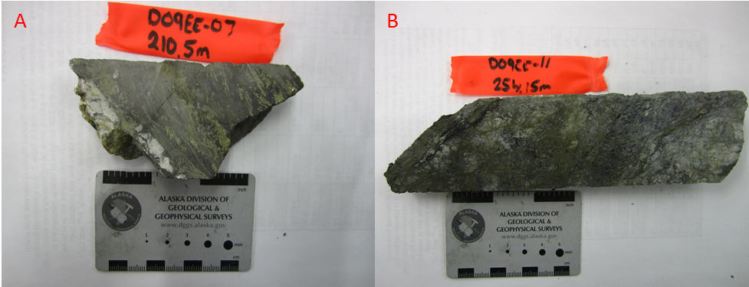
Figure 1 : Hand sample photos of (A) banded mineralization of sphalerite, pyrite and chalcopyrite from D09EE07_210.5m, and (B) brittle brecciation of quartz, siderite and pyrite from D09EE11_254.15m.
The first phase of mineralization that is described as Stage 1 in the paragensis by Hantelmann (2013) comprises quartz veining. Vein quartz has undulatory extinction, medium sized grains can contain abundant fluid inclusions (“dirty quartz”), and most significantly, grains do not align with foliation. Grain boundaries are usually distinct and can range from wavy to straight. Quartz veins are cut by subsequent mineralization and are commonly occurs as clasts in later mineralization. Quartz is sometimes present at the Eagle Vein.
The second phase of mineralization (Stage 2, Hantelmann, 2013) comprises coarse grain euhedral siderite with rhombohedral cross-hatching, moderate to high concentrations of inclusions, and undulatory extinction and is present in all samples.
A second phase of very fine grained siderite usually brecciates the first phase. The finer grains are in thinner brecciating pathways with clasts of the coarse grain siderite. Grains are ‘very dirty’ with abundant inclusions. This phase is interpreted to be Stage 6 (Hantelmann, 2013).

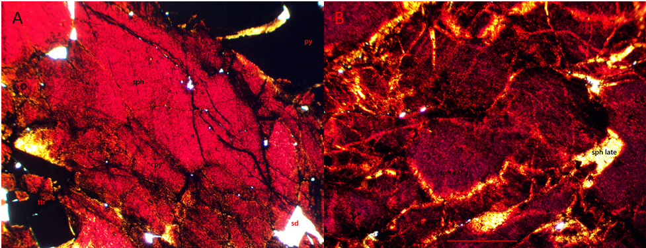
Figure 2 : Photomicrographs in plane polarized light of sphalerite colour variation in (A) from blood red to orange near pyrite in D09EE07_210.50m, and (B) from red to orange near fractures in D09EE07_212.20m.
Sphalerite is abundant in the Eagle Vein containing an average of 40% in the samples taken. The sphalerite is generally coarse grained, subhedral, isotropic, and is usually blood red, but can have colour zonation going to a lighter orange-yellow near pyrite bands (Figure 2A,B). It also has abundant micro-inclusions, often has a network of fractures and is often interbanded with pyrite and/or chalcopyrite. Sphalerite is also present in later fault breccia pathways as clasts. All sphalerite seen within the samples collected are interpreted to be Hantelmann’s Stage 7.
Chalcopyrite is also in the Eagle Vein where it is associated with sphalerite, either as small abundant flecks (Figure 3A,B; 4B) or as long elongated strands parallel to flow banding (Figure 3B; 4A). Chalcopyrite is yellow-gold in reflected light, opaque in transmitted light and occasionally in exsolution with lesser tetrahedrite. It is interpreted to be Hantelmann’s Stage 7.

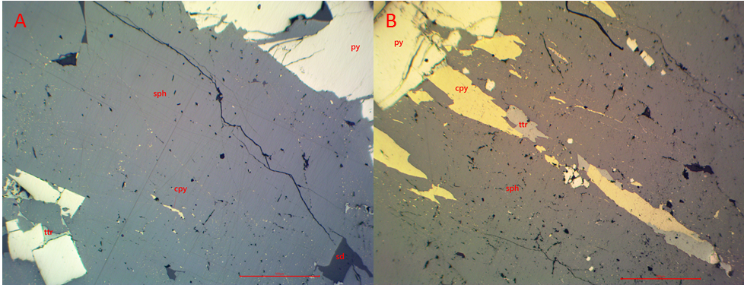
Figure 3 : Photomicrographs in reflected light of D09EE07_210.50m showing (A) chalcopyrite as small inclusions in sphalerite and (B) as discontinuous elongated strands parallel to flow banding. (B) also has associated tetrahedrite. Red scale bars are 500µm.

Pyrrhotite occurs as trace blebs within some arsenopyrite and chalcopyrite grains in sample D09EE07_210.50m. It is brown with tinge of maroon in reflected light, and opaque in transmitted light. Tetrahedrite is also found associated with chalcopyrite and the flow banding (Figure 3A,B). It is medium grey in reflective light, opaque in transmitted light and is typically elongated with flow banding as small clasts. In some areas, it is in exsolution with lesser lighter grey mineral (galena?). It can also occur in fractures cutting through the sphalerite. This is interpreted to be Stage 7 (Hantelmann, 2013).
Pyrite occurs at various stages. One stage aligns into bands with sphalerite, and sometimes chalcopyrite (Figure 3A; 5C,D). These are coarse to medium grained, euhedral, fractured and while overprinting earlier mineralization, it is considered to have deposited pre-flow banding. Grains are occasionally melded together. In samples where there is less strong flow banding, it occurs as a netting of pyrite following fractures. The banding and overprinting typically occurs in samples that have more flow banding and less brecciation. This is interpreted to be Hantelmann’s (2013) Stage 7+. In areas of brecciation, pyrite occurs in the matrix or associated with fractures (Figure 5A,B). It is fine to medium grained, subhedral, weakly fractured, and weakly corroded. This interpreted to be at least Stage 7, as it cuts through Stage 6 siderite.

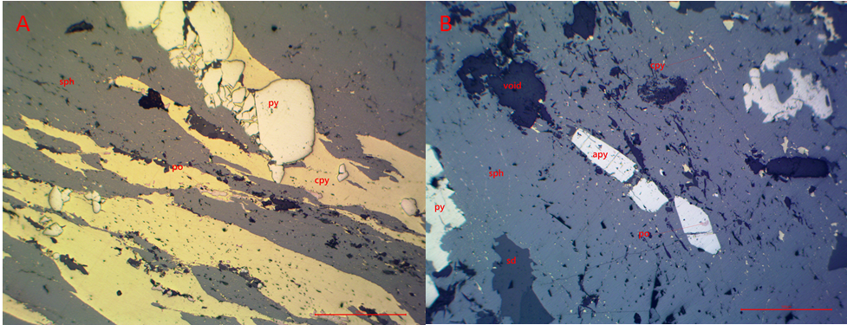
Figure 4 : Photomicrographs in reflected light from D09EE07_210.50m of (A) chalcopyrite stands in flow banding with sphalerite with pyrrhotite and associated pyrite. (B) is aligned grains of arsenopyrite with inclusions of pyrrhotite and chalcopyrite flecks in sphalerite. Red scale bar is 500µm.

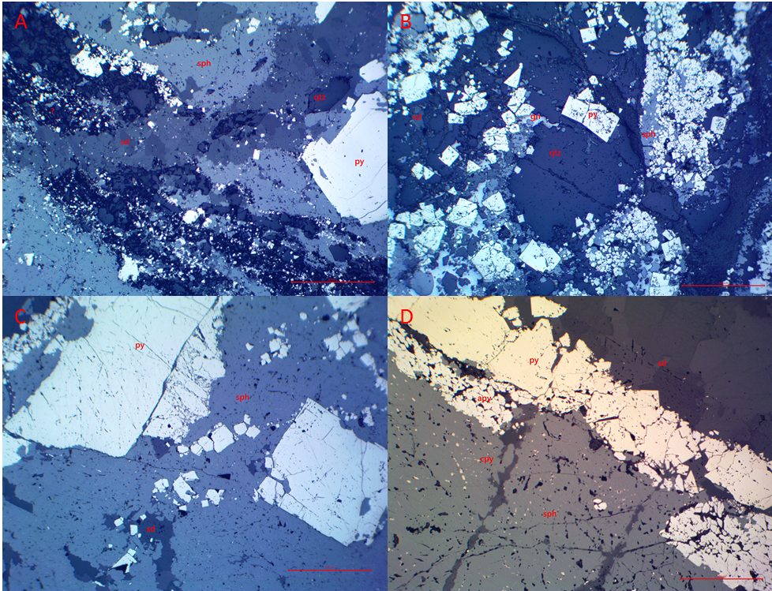
Figure 5 : Photomicrographs in reflected light of pyrite in breccia matrix and fractures in (A) from D09EE07_212.2m and (B) from D09EE11_254.1m. Pyrite clusters aligned parallel to flow in (C) from D09EE07_213.35m and (D) from D09EE11_263.4m. Red scale bar is 500µm.
Arsenopyrite is present in minor amounts in the banded mineralization. The subhedral, elongated grains cluster in strands that are parallel with banding and are observed to be white-grey in reflected light and are commonly corroded (Figure 5D). Some arsenopyrite can contain blebs of pyrrhotite (Figure 4B). Like the banded pyrite, it is interpreted to be part of Hantelmann’s Stage 7+.
Galena can be present in trace amounts in the banded mineralization and within the matrix of fault breccias. Galena contains blebs and patches of exsolved tetrahedrite within some samples. In breccias, it is a minor mineral, filling empty spaces in matrix of fault breccias and is typically overprinted by fine grained corroded subhedral pyrite. It occurs preferentially between siderite grains (Figure 3B) and is correlated with Hantelmann’s Stage 8a.
Boulangerite occurs in the banded mineralization associated with the coarse grain siderite and sphalerite as needles or elongated patches in D09EE07_212.2m (Figure 6). It is grey in reflective light with brown tarnish. This is most likely correlated with Hantelmann’s Stage 8b.

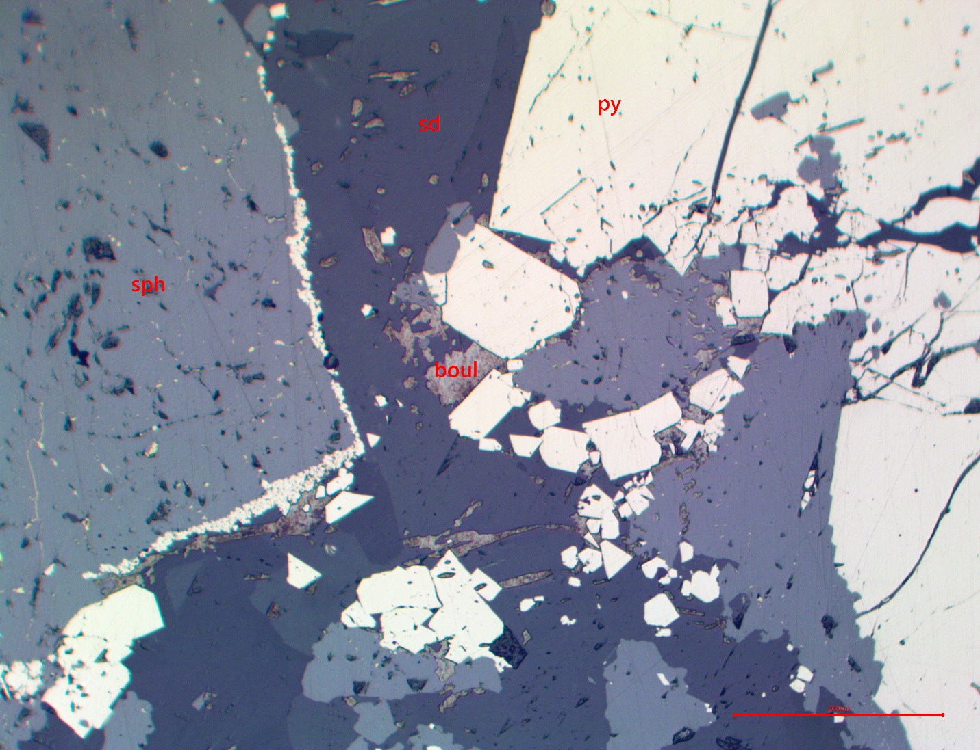
Figure 6 : Photomicrograph in reflected light of siderite cut by sphalerite from D09EE07_212.2m. Needles and patches of boulangerite cut sphalerite and siderite. Late pyrite overprints all earlier mineralization. Red scale bar is 200µm.
One post-argentiferous mineralization stage of carbonate is seen in the samples taken (Stage 12) in D09EE11_264.50m. The carbonate is most likely siderite. It is red-orange in transmitted light, very fine grained and cuts through earlier quartz and siderite mineralization.

References
Hantelmann, J.J. (2013) The paragenesis and geochemistry of the Bellekeno Ag-Pb-Zn vein, Keno Hill district, Yukon, Canada. University of Alberta, Master’s Thesis, pp. 81.
Tupper, D.W. (2010). Eagle Project Diamond Drilling Assessment Report, Keno Hill Area, Mayo Mining District, Yukon. YGS Open File Report 095672, pp. 342.
Whitney, D.L., Evans, B.W. (2010). Abbreviations for names of rock-forming minerals. American Mineralogist, 95, p. 185-187.

Appendix I: Paragenesis

Taken from Hantelmann (2013).

Stage 1: Qtz ± Py, Apy; ±Minor: Au, Tour, Musc {Sph, Gn, Cpy?}
- Predominantly Qz and commonly intergrown with highly variable amounts of Py and/or Apy.
- Au may be present – likely requires back checking of assay results.
- NOTE: minor pockets of Sd, Sph, Gn, Cpy, Boul may be present within and associated/approximately coeval with this stage (?) – this requires further investigation.
- NOTE: observations from the Flame vein suggest that this stage is relatively abundant (significantly more common than in Bellekeno), and that this assemblage may be overprinted and potentially dissolved/re-incorporated into later stages – this may have locally affected vein chemistry, and exhibits different apparent mineral associations.
- NOTE: Qtz mineralization may be more effectively classified into 4 sub-types.
- Metamorphic: these will always follow foliation, may contain irregular stringers of phyllitic material.
- Early Qtz: veinlets and veins of essential clean Qtz; there are likely multiple generations; these may cross-cut or follow foliation.
- Qtz (±Apy, Py): commonly as massive veins; easily identifiable based on mineral assemblage. This mineral assemblage is commonly associated with elevated Au-content.
- Qtz (±Sd, Sph, Gn): veinlets and veins that commonly contain irregular pockets of Sd, Sph, and lesser Gn. Based on geochemical characterization, this mineral assemblage appears to be slightly elevated in Ag-content; and is inferred to be more closely related (temporally) to stage 2.

Stage 2: Sd ± Qtz, Py, {Cpy?}; ±Minor: Po, Apy, Cst
- Comprised of predominantly Sd; can have a variety of textures.
- This stage may transition to, or be variably intergrown with stage 3.
- Lacks association with Gn or Ag-bearing minerals.
- The variable presence of Py and/or Cpy requires further investigation.

Stage 3(a): Sph; ±Minor: Qtz, Py, Po, Apy, Cst, Gn
- Sp is generally dark purple (at hand sample scale), due to high Fe-content.
- This stage follow/transition from stage 2 (i.e. stage 2 and 3 may be approximately coeval and variably intergrown) – may help distinguish stage 2.

Stage 3(b): Gn
- Gn generally occurs as small pockets within stage 3a sphalerite
- This stage is closely associated with stage 3a; in some veins or localized areas Gn may be more volumetrically abundant, hence the creation of this sub-unit.

Stage 3(c): Cal ±Minor Ank
- Cal may occur as pocket, veinlets, or less commonly as veins and breccias.
- This stage in-fills after or cross-cut stages 2 and 3; comparable to stage 12, but volumetrically more minor and distinguished based on the spatial (temporal) association with the 1 generation stages.

Stage 3-5: Sph-Gn ±Minor: Qtz
- Sph appears to be dark purple, commonly occurring as a breccia cement.
- Gn is also commonly associated with Sph, there does not appear to be any significant Ag-bearing minerals associated with this stage – possibly the Ag-content is contained within the galena structure here (?).
- Sd appears to be absent (i.e. not coeval), but may occur as clasts.
- NOTE: this is a newly identified stage and not well constrained.

Stage 4a: Py-Sph; ±Minor: Apy, Cst, Gn
- Sph similar to stage 3 (i.e. dark purple - at hand sample scale), however distinguishable based on close association with abundant slightly earlier Py.
- Py is generally earliest in this stage – commonly occurring at vein edges.
- This stage commonly cross-cuts the earlier (above) stages, or into wall-rock; distinct event, behaved differently that all other stages – this may be clearly visible when logging mineral assemblages/facies.

Stage 4b: Qtz; ±Minor: Py, Apy, Cst, Gn
- Qtz occurs as veinlets and has only been observed within or immediately around stage 4a – may be useful to distinguish stage 4a.
- NOTE: this stage is volumetrically insignificant.

Stage 5: Sd-Gn; ±Minor: (5b: Ttr, Plb, Pyr, Stb, Boul, Jam?)
- Variable ratios of Sd and Gn, approximately coeval – this stage may be distinguishable based on the Sd-Gn association alone.
- NOTE: the absence of associated Sph – if Sph is present in the vicinity, be sure to determine that any Sp is indeed a distinct event/stage, and that there is no approximately coeval Sd-Sph-Gn association.
- Gn in this stage may exhibit shearing textures (syn-genetic?).
- The relative timing of this stage is not well constrained – it may post-date stage 8, but defines a different mineralizing event from stage 8.
- Ag-bearing minerals are inferred to be present (based on assay results, not confirmed/observed in any detailed samples).

Stage 6: Sd ± Qtz, Py; ±Minor: (8b: Ccp, Boul?)
- Comprised of predominantly Sd, may have a variety of textures.
- This stage may transition to, or commonly associated with (may or may not be variably intergrown) stages 7 and 8 – may be useful to distinguish.

Stage 7a/b: Py
- Py may be variably intergrown with stage 6 Sd; however a distinct event of Py post-dates stage 6, occurring as veinlets, or fracture-filling, possibly the same as some Py-rich veins and breccias.
- NOTE: this is a newly identified stage and is not well constrained.

Stage 7: Sph ± Qtz, Py; ±Minor: (8b: Ccp, Ttr, Plb, Stn, Aca, Snn, Cnf)
- Sph may occur as blebs, pockets, veinlets, massive veins, or breccia cement – the association with stages 6 and 8 may be useful to distinguish.
- Sph is generally lighter purple (compared to stages 3 and 4a), due to relatively less Fe-content.
- Sph commonly follows/transitions from, or is intergrown with stages 6 and 8, and may also be intergrown with or spatially associated with a variety of Ag-bearing minerals.
- NOTE: observations of the Flame vein Sph may not be lighter – possibly due to the presence of abundant Py (remnant, coeval, remobilized?).
- NOTE: a variety of Ag-bearing minerals are commonly intergrown with or spatially associated with this stage – particularly in the Flame vein.

Stage 8(a): Gn ± Qtz, Py; ±Minor: (8b: Ccp, Ttr, Plb, Pyr, Stn, Aca? Boul, Jam?)
- Gn may occur as blebs, pockets, veinlets, massive veins, or breccia cement – the association with stages 6 and 7 may be useful to distinguish.
- Gn commonly follows/transitions from, or is intergrown with stages 6 and 7.
- NOTE: a variety of Ag-bearing minerals are commonly intergrown with or spatially associated with this stage.

Stage 8(b): Ccp, Ttr, Plb, Pyr, Stn, Boul?, Jam?, Snn, Cnf
- This stage may occur as blebs, pockets, veinlets, micro-breccias; commonly closely associated with stages 7 and 8, as well as 6 – the spatial association may be useful to distinguish stages 6 or 7.
- NOTE: all of these minerals are typically present only in minor amounts and may not be visible at the macroscopic scale.

Stage 9: Sd-Ank-Sph ± Minor: Py, Gn
- This stage is defined by a characteristic colloform or oscillatory layers/ banding of Sd-Ank (at the macroscopic scale Sd appears to be type I: cloudy, creamy), with variably abundant Sph, and less common pockets or blebs of Py and Gn.
- This stage may transition from stage 8, or also from earlier stages is also possible, and commonly occurs as rinds or crustiform layers in breccias.
- NOTE: Rare Ag-bearing minerals may be intergrown in this stage (?).

Stage 10: Qtz
- Qtz occurs as veinlets, smaller (generally <10 cm wide) veins and breccia cement – very different compared to stage 1.
- This stage commonly follows/transitions from, or is closely associated with stages 9 – may be useful to distinguish it.
- NOTE: this stage is volumetrically insignificant.

Stage 11: Sd
- This stage is not well constrained – there is evidence of multiple Sd mineralizing events/stages.
- NOTE: this stage is volumetrically insignificant, only a few clear examples of this stage have been observed.

Stage 12: Cal
- Cal may occur as veinlets, massive veins, or breccia cement.
- This stage commonly follows/transitions from, or is closely associated with stages 9 or 10 – this may help distinguish any of these stages.

Appendix II: Petrographic Descriptions and Photos

Descriptions of thin sections from petrography completed January to March 2017 from drill core samples from the Eagle property.

Hole: D09EE07 Depth: 210.5m Assay #: 075787 Vein: Eagle

Ag (ppm) | Au (ppm) | Pb (ppm) | Zn (ppm) | As (ppm) | Cd (ppm)
805 | 0.479 | 1170 | 280400 | 2053 | 3550

Macroscopic description of sample:
Pyrite, chalcopyrite, and sphalerite banded vein overprinting quartz. ~1m from main vein structure

Mineral | Modal % | Mineral Observations and Textures
Siderite | 1 | As small clasts within the pyrite, chalcopyrite, and sphalerite banding. Siderite is coarse grain, has high birefringeance, undulose extinction,
Quartz | 9 | As large clasts on one corner of the thin section, and as small clasts throughout banding of pyrite, sphalerite, and chalcopyrite. Very coarse grain with indistinct grain boundaries, undulose extinction, and no directionality of grains. Some linear pathways of fine grain recrystallized quartz within the coarse grains.
Sphalerite | 54.5 | Banded with pyrite and chalcopyrite. Blood red with strands of orange in transmitted light. Changes colour to orange cutting through pyrite fractures in pyrite bands (3,4).
Pyrite | 30 | Coarse to medium grain, euhedral, fractured pyrites. Aligned into bands with sphalerite and chalcopyrite (5).
Chalcopyrite | 5 | As small flecks throughout sphalerite bands (1,2), and larger strands that align with flow banding (3,5). Yellow-gold in reflected light, opaque in transmitted light. Occasionally in exsolution with lesser tetrahedrite.
Arsenopyrite | 0.5 | Fine to medium grained clusters of white-grey mineral in reflected light. Clusters align with banding. Can sometimes have blebs of pyrrhotite (1). Pocked/corroded with rounded edges. With a fault breccia with clasts of siderite, sphalerite, quartzite, and Arsenopyrite (6).
Pyrrhotite | 0.01 | As blebs within some Arsenopyrite (1) and chalcopyrite (5) grains. Brown with tinge of maroon in reflected light.
Tetrahedrite | 0.1 | Medium grey in reflective light, opaque in transmitted light. Elongated with flow banding, small clasts (2,3). In exsolution with lesser lighter grey mineral (galena?). Is usually associated with the longer strands of chalcopyrite. In fractures cutting through the sphalerite
Galena | 0.01 | As lesser blebs and patches (light medium grey in reflected light) in exsolution with tetrahedrite (medium grey in reflected light) (2).

Textures and Cross-Cutting relationships:
Qtz<?sd<py<sph<cpy-ttr-gn~po=~banding movement<apy w/ late flt bx

Paragenesis and Hantelmann’s 2013 Scheme
 | Stage description | Paragenesis Level
 | Coarse grain siderite | 2
 | Pyrite | 7a/b? 4a?
 | Sphalerite | 7
 | Chalcopyrite with lesser tetrahedrite, galena and pyrrhotite | 8b
 | Arsenopyrite | ?

Photos:
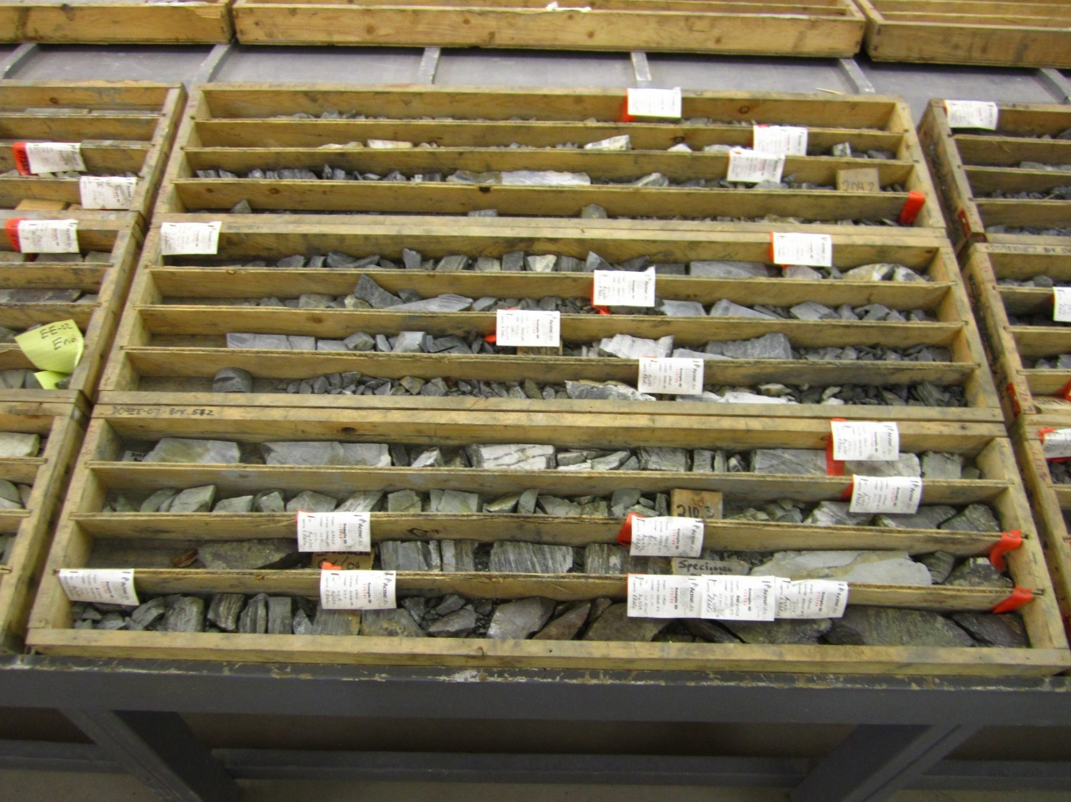
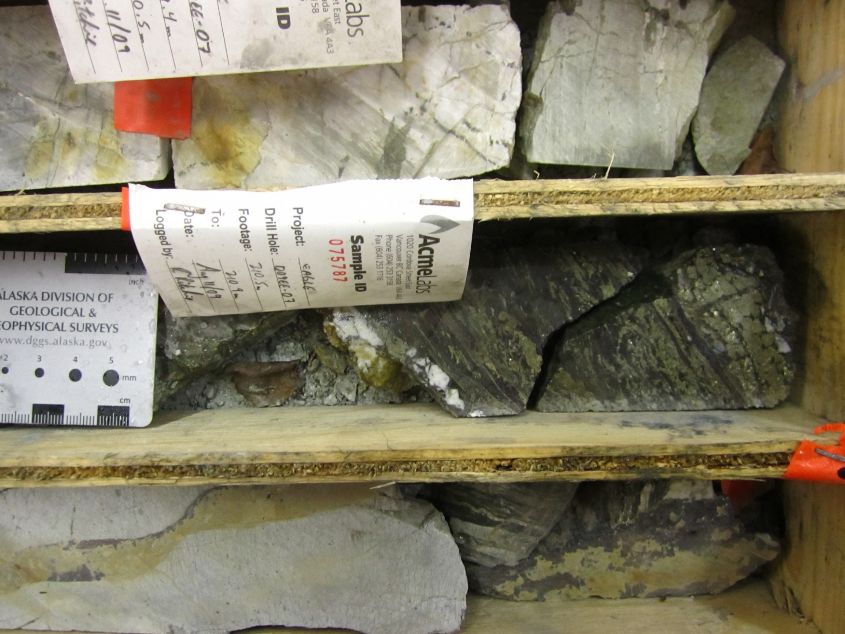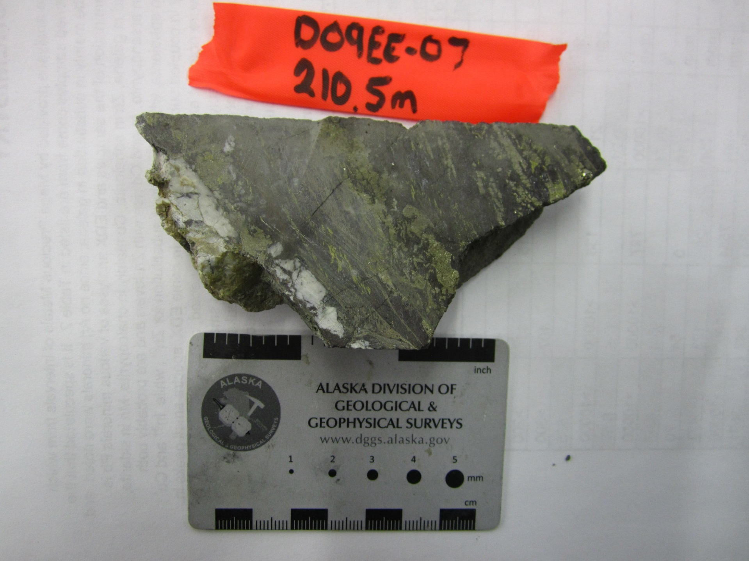
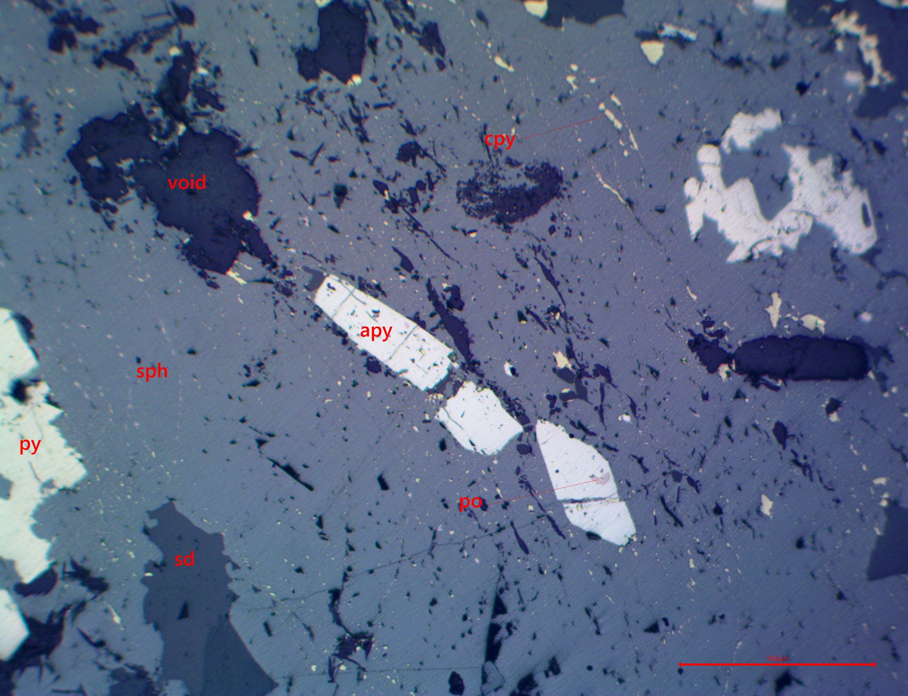
Figure 1 : Photomicrograph in reflected light of sphalerite with specks of chalcopyrite. Grains of arsenopyrite with blebs of pyrrhotite align with banding, as well as pyrite and clasts of siderite. Red scale bar 500µm.
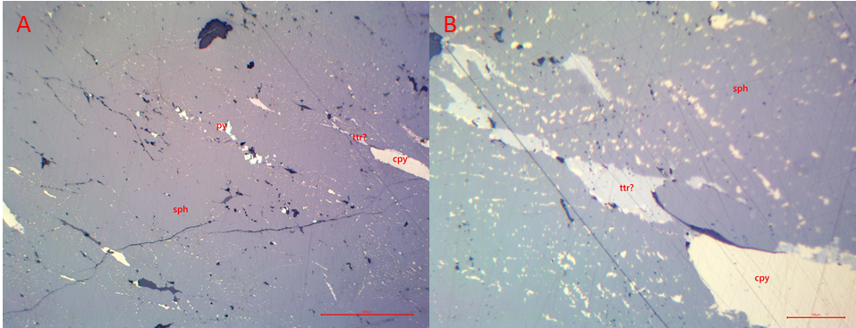
Figure 2 : Photomicrographs in reflected light of sphalerite with aligned flecks and strands of chalcopyrite. Strands of tetrahedrite and pyrite also aligned with flow banding. Red scale bar is (A) 500µm and (B) 50µm.

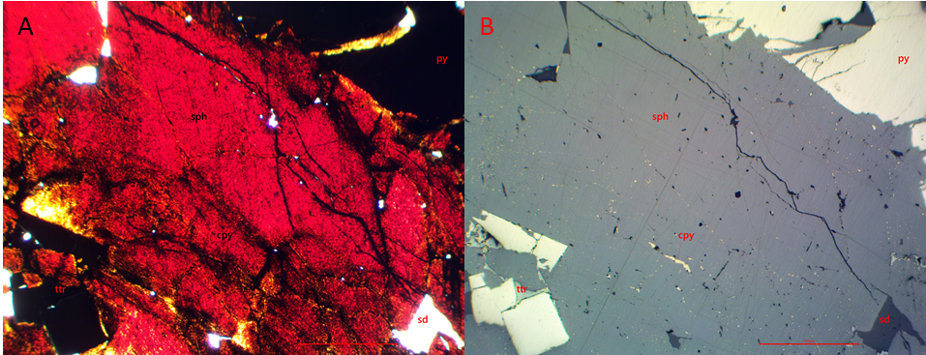
Figure 3 : Photomicrographs in (A) plane polarized and (B) reflected light of banded sphalerite with flecks of chalcopyrite and pyrite. Tetrahedrite can be associated with pyrite. Red sphalerite has colour variation proximal to pyrite. Red scale bar is 500µm.
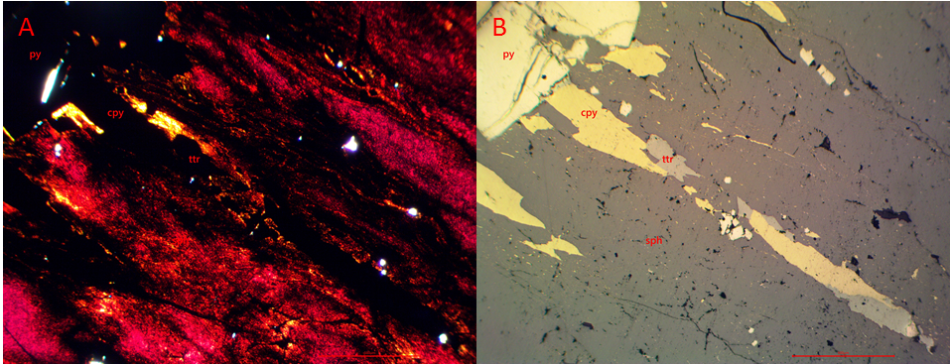
Figure 4 : Photomicrograph in (A) plane polarized, and (B) reflected light of banded sphalerite with minor strands of chalcopyrite and tetrahedrite. Flecks of chalcopyrite aligned in sphalerite. Pyrite in clusters aligned with bandings. Red scale bar 500µm.
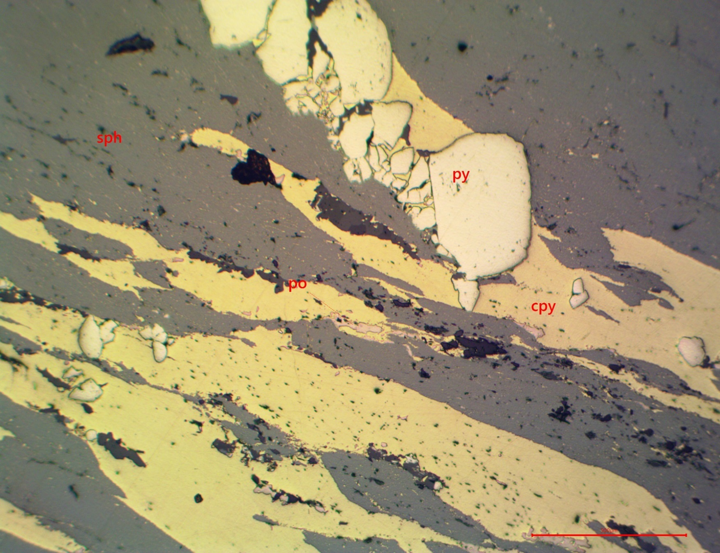
Figure 5 : Photomicrograph in reflected light of banded sphalerite and chalcopyrite. Pyrrhotite blebs found in chalcopyrite. Pyrite overprinted chalcopyrite. Red scale bar 500µm.
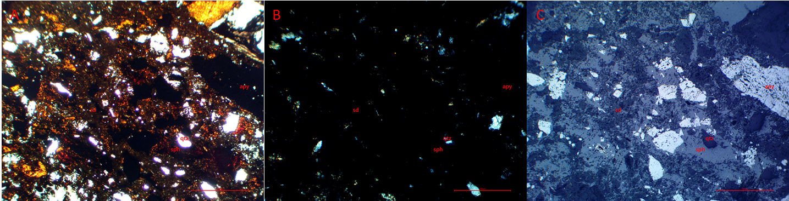
Figure 6 : Photomicrographs in (A) plane polarized, (B) cross polarized, and (C) reflected light of a fault breccia with clasts of quartz, siderite and arsenopyrite, and matrix of sphalerite. Red scale bar 500µm.

Hole: D09EE07 Depth: 212.20m Assay #: 075791 Vein: Eagle

Ag (ppm) | Au (ppm) | Pb (ppm) | Zn (ppm) | As (ppm) | Cd (ppm)
108.9 | 0.203 | 376 | 329800 | 673 | >4000

Macroscopic description of sample:
Sphalerite vein with minor siderite and quartz. Netting of very fine grain pyrite. Possible very fine grain galena. From main vein structure.

Mineral | Modal % | Mineral Observations and Textures
Quartz | 10 | Long clasts of quartz in sphalerite. Quartz has varying sizes from fine to medium grain, with euhedral grains, some of which are prismatic. Unknown fine grain prismatic mineral brecciates the quartz, and sphalerite follows this brecciation and along and between quartz grain boundaries (3,4).
Mystery | 0.5 | Thin prismatic rods of an unknown mineral. Clear in ppl, brown to blue translucent in xpl, dark in reflected light (3,4). Forms preferentially between grains of quartz, and brecciates the quartz in quartz clasts.
Siderite | 0.5 | Coarse grain siderite as clasts in sphalerite. Fine grain siderite stringer cuts through sphalerite and quartz, but prior to pyrite (4).
Sphalerite | 86 | Two phases of sphalerite. The first is a blood red “dirty” sphalerite that comprises most of the sphalerite (and the thin section), and the second is a netting of orange to yellow sphalerite that can follow thin fractures (1). Alternately, the second phase could be a leaching of the first phase around fractures.
Pyrite | 3 | Netting of very fine grain pyrite following fractures, which preferentially forms along elongated clasts of quartz (4).
Boulangerite | 0.05 | Grey in reflective light with brown tarnish. In needles or elongated patches in coarse grain siderite (2).

Textures and Cross-Cutting relationships:
Quartz<cg sd(-boul?)<sph<fg sd<fractures-myst-pyrite

Paragenesis and Hantelmann’s 2013 Scheme
 | Stage description | Jos’ Paragenesis Level
 | Coarse grain siderite | 2
 | Boulangerite | ?
 | Sphalerite | 7
 | Fine grain siderite | 6
 | Fractures with pyrite | 7a/b

Photos:
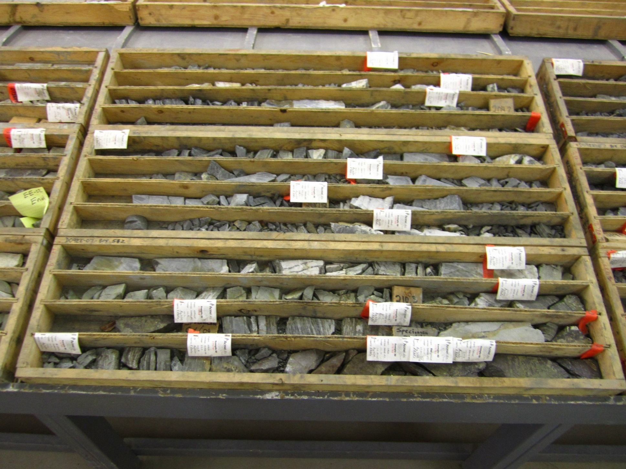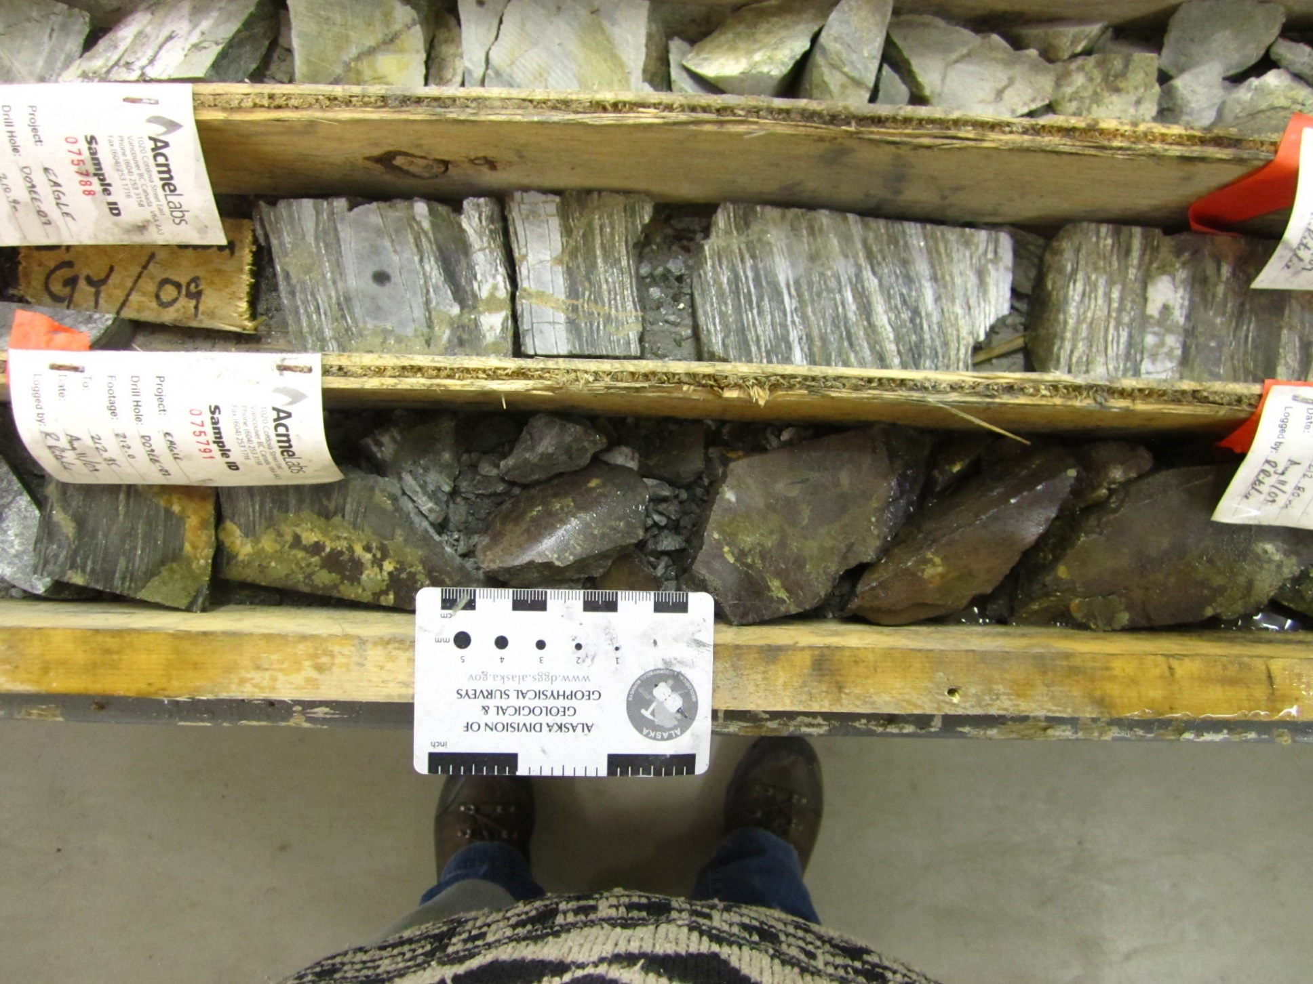
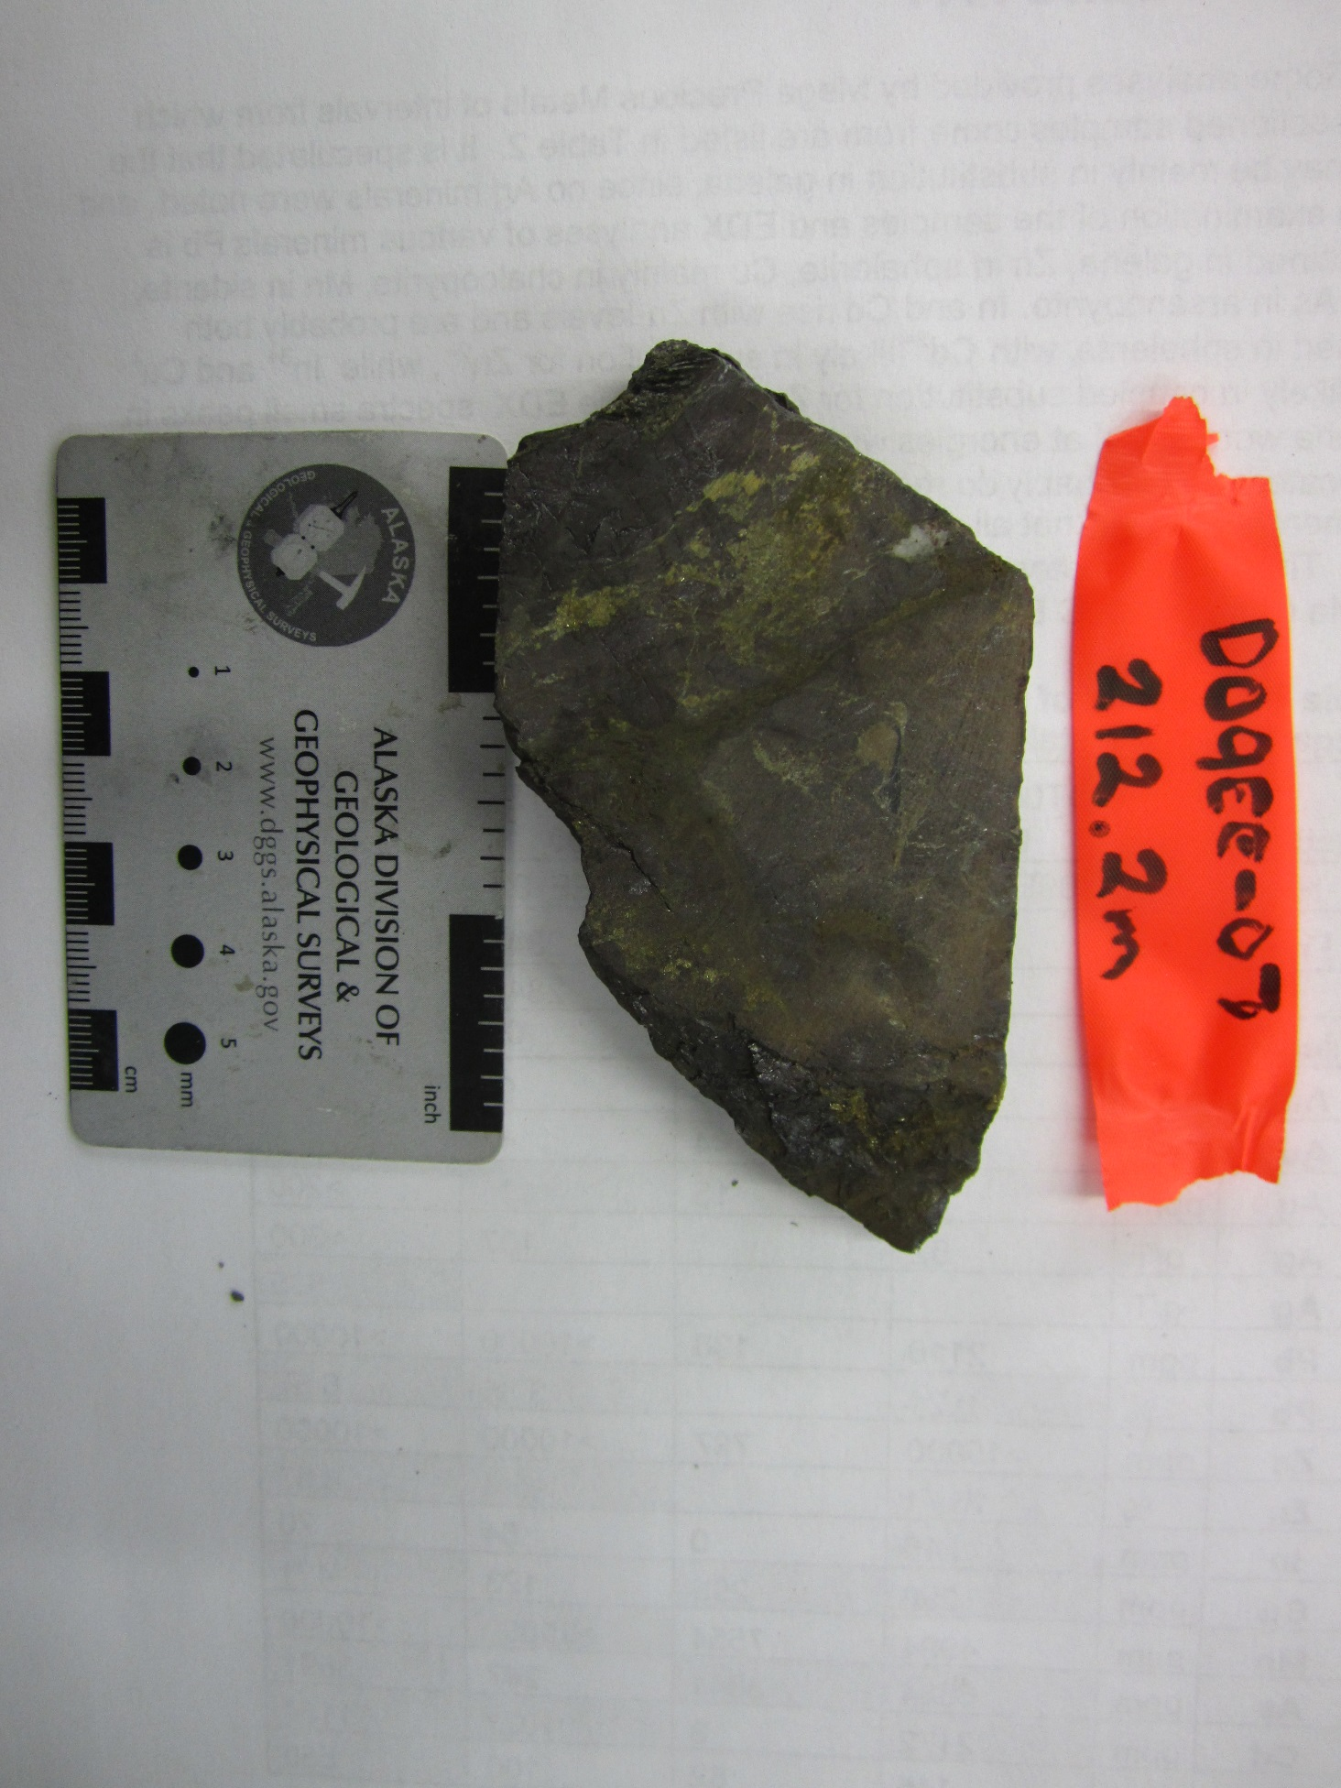
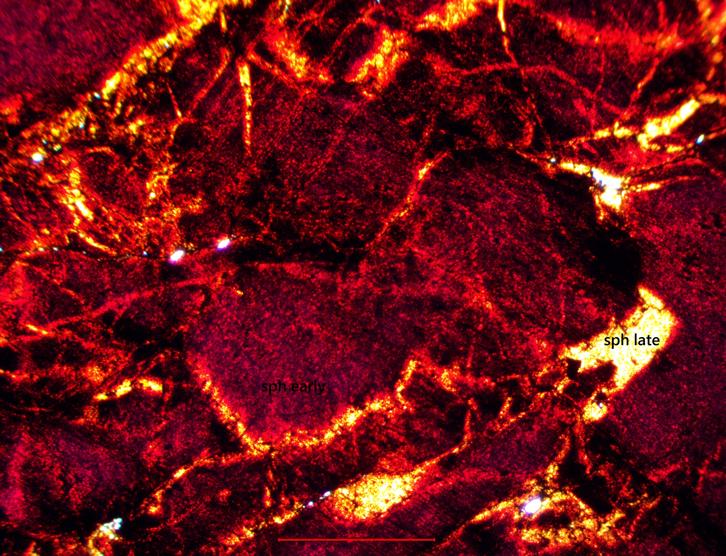
Figure 1 : Photomicrograph in plane polarized light of sphalerite with fractures. Sphalerite is yellow near fractures and red away from fractures. Red scale bar 500µm.
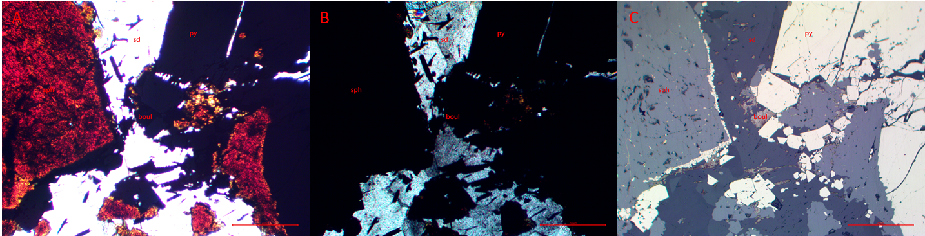
Figure 2 : Photomicrographs in (A) plane polarized, (B) cross polarized, and (C) reflected light of siderite cut by sphalerite. Pyrite overprints earlier sphalerite as coarse grain, and between siderite and sphalerite as fine grain pyrite. Boulangerite overprints siderite. Red scale bar 200µm.

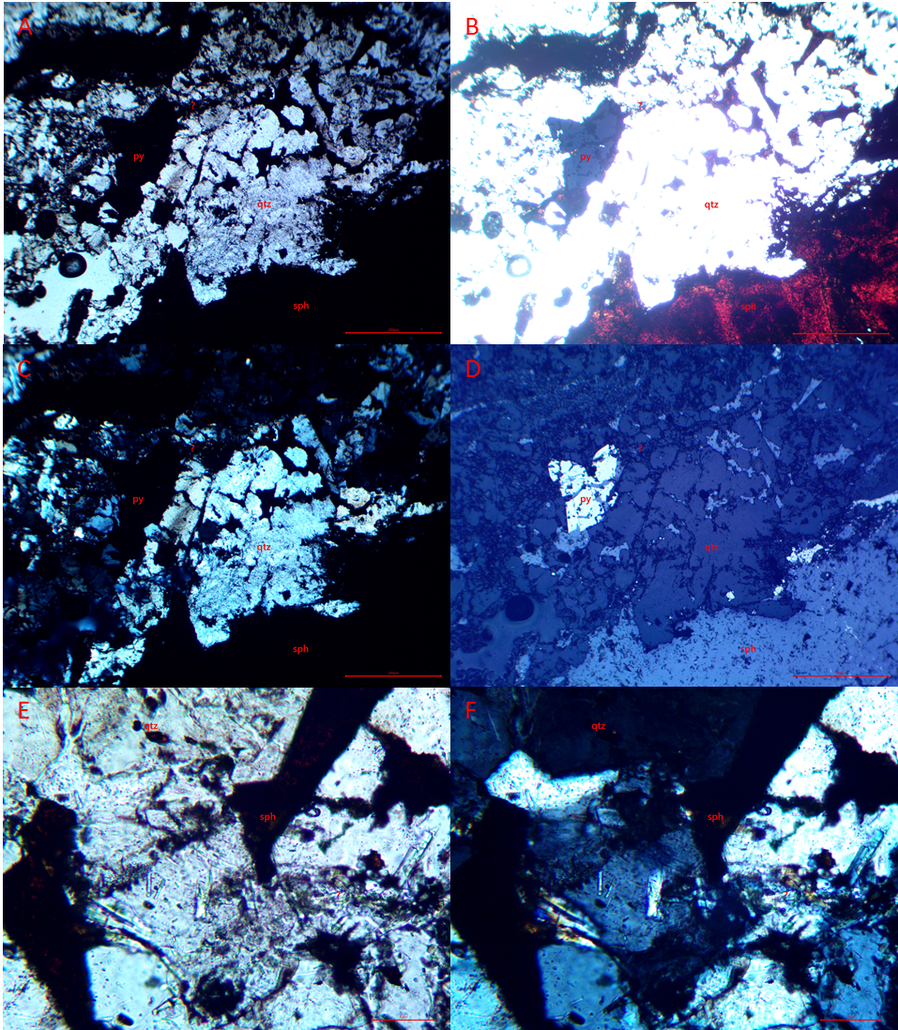
Figure 3 : Photomicrographs in (A,E) plane polarized, (B) bright plane polarized, (C,F) cross polarized, and (D) reflected light of sphalerite cutting quartz. Unknown prismatic mineral overprinting quartz. Red scale bar (A-D) is 500µm and (E-F) is 50µm.
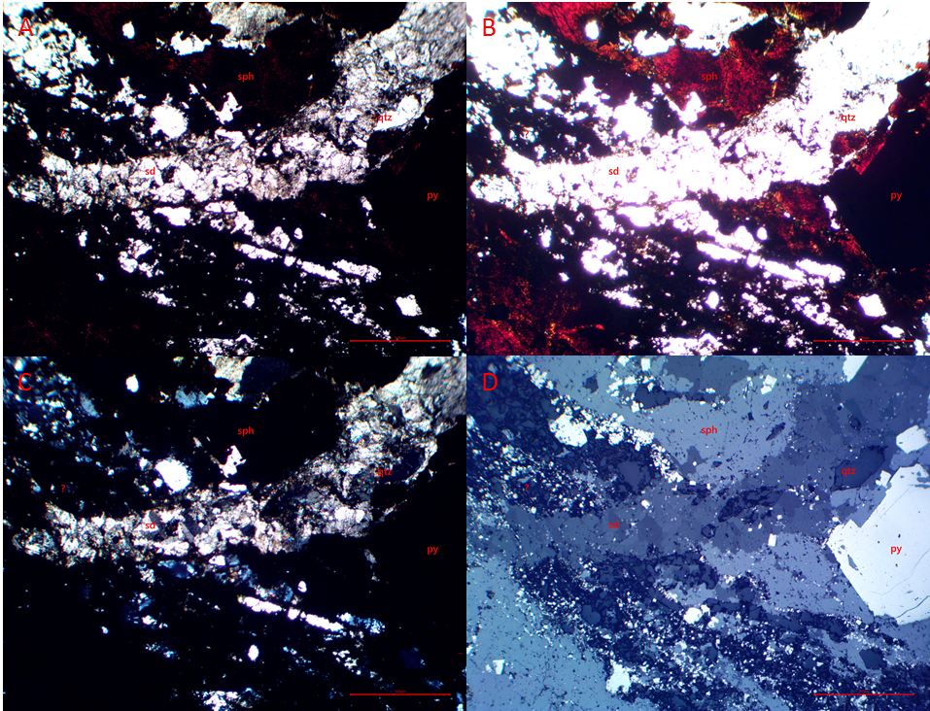
Figure 4 : Photomicrographs in (A) plane polarized, (B) bright plane polarized, (C) cross polarized, and (D) reflected light of a fault breccia with clasts of quartz, siderite, and pyrite. Matrix filled with sphalerite. Siderite veinlet cuts sphalerite and fault breccia. Red scale bar 500µm.
Hole: D09EE07 Depth: 213.35m Assay #: 075795 Vein: Eagle

Ag (ppm) | Au (ppm) | Pb (ppm) | Zn (ppm) | As (ppm) | Cd (ppm)
88.6 | 0.369 | 518 | 303400 | 555 | >4000

Macroscopic description of sample:
Sphalerite-galena-siderite vein with late coarse grain pyrite.

Mineral | Modal % | Mineral Observations and Textures
Siderite | 15 | Coarse grain siderite with euhedral grains, undulatory extinction. Cut and ground by later fractures containing pyrite (1).
Sphalerite | 65 | Blood red sphalerite with some orange around fractures. Cuts through coarse grain siderite, with some clasts of siderite in the sphalerite (3). Overprinted by pyrite (2,3).
Pyrite | 20 | Fractures contain clusters of fine grain, subhedral, rounded pyrite, which cuts earlier sphalerite, siderite, and coarse grain pyrite (3). Coarse grain euhedral pyrite overprints sphalerite (2).

Textures and Cross-Cutting relationships:
Sd cg<sph<cg py<fg py-fract

Paragenesis and Hantelmann’s 2013 Scheme
 | Stage description | Jos’ Paragenesis Level
 | Coarse grain siderite | 2
 | Sphalerite | 7 (4a)
 | Coarse grain pyrite | 7a/b (4a)
 | Fine grain pyrite | ? (7a/b)

Photos: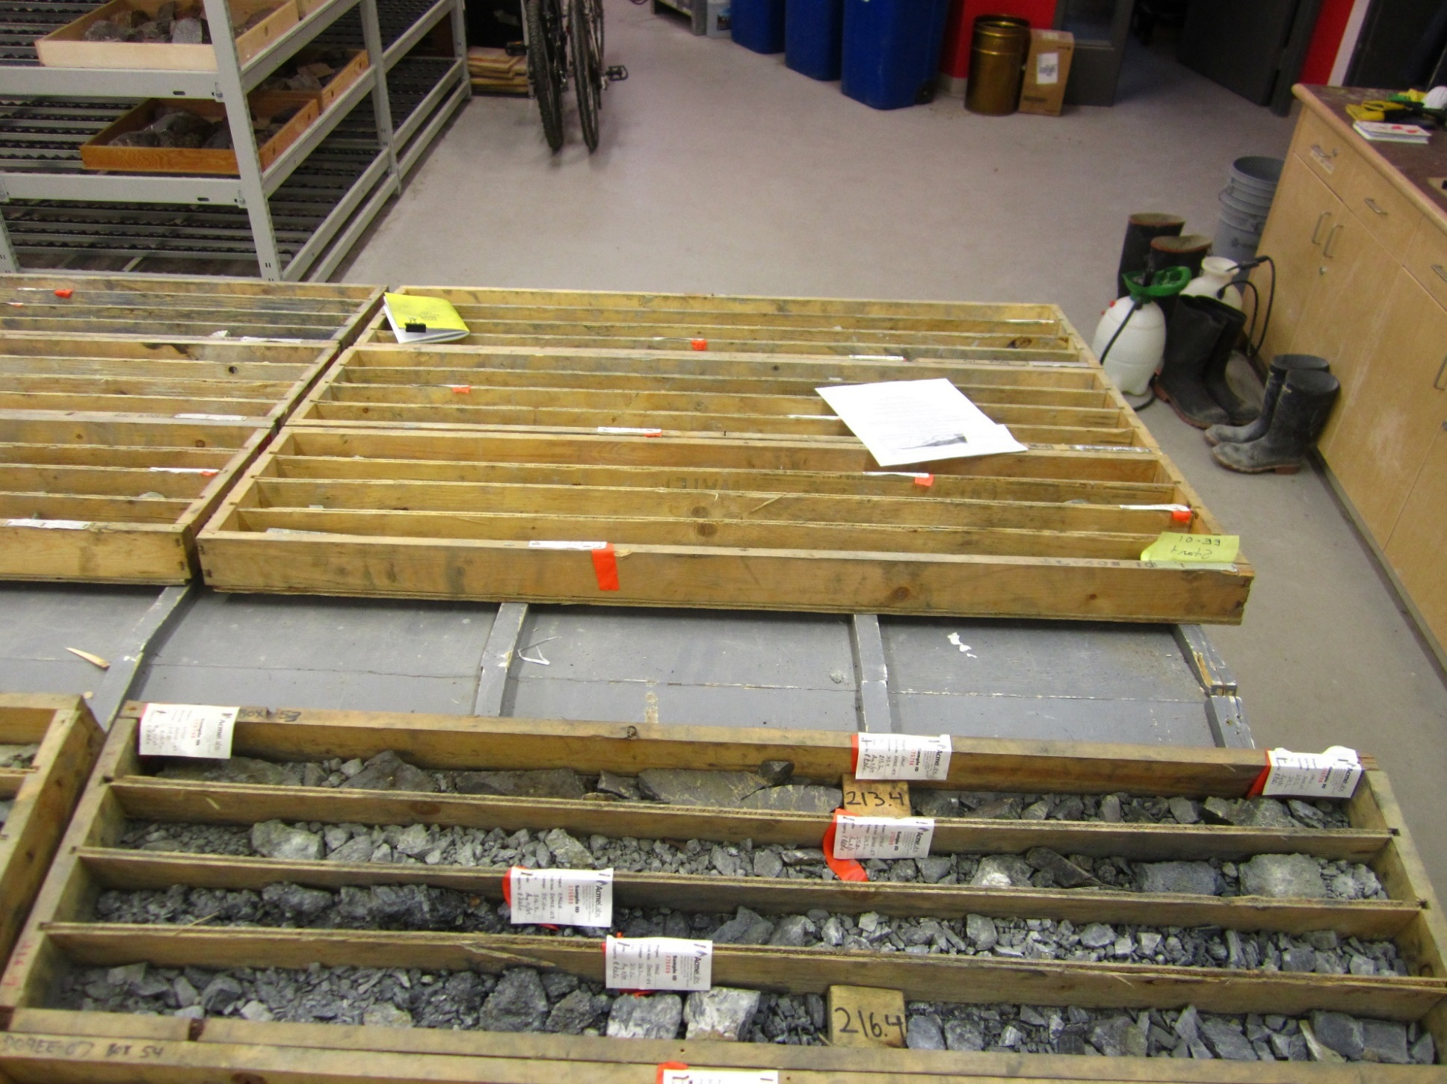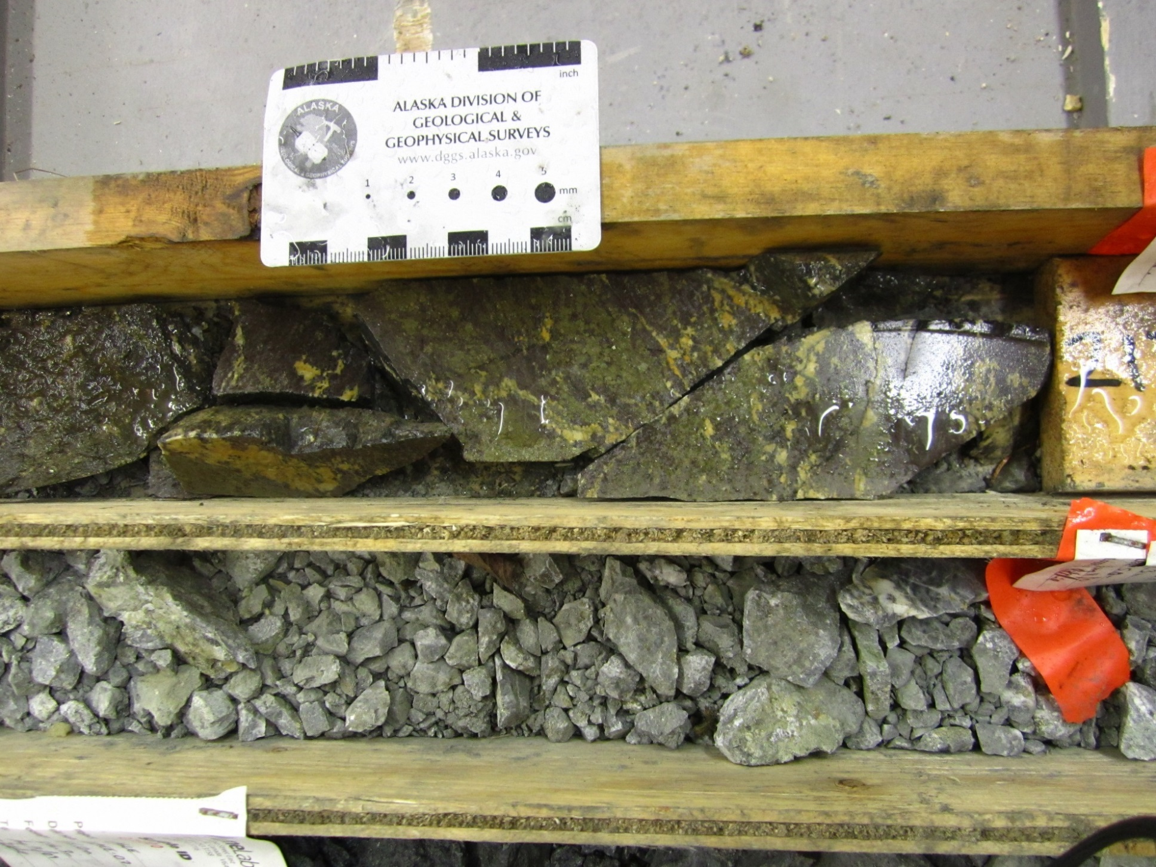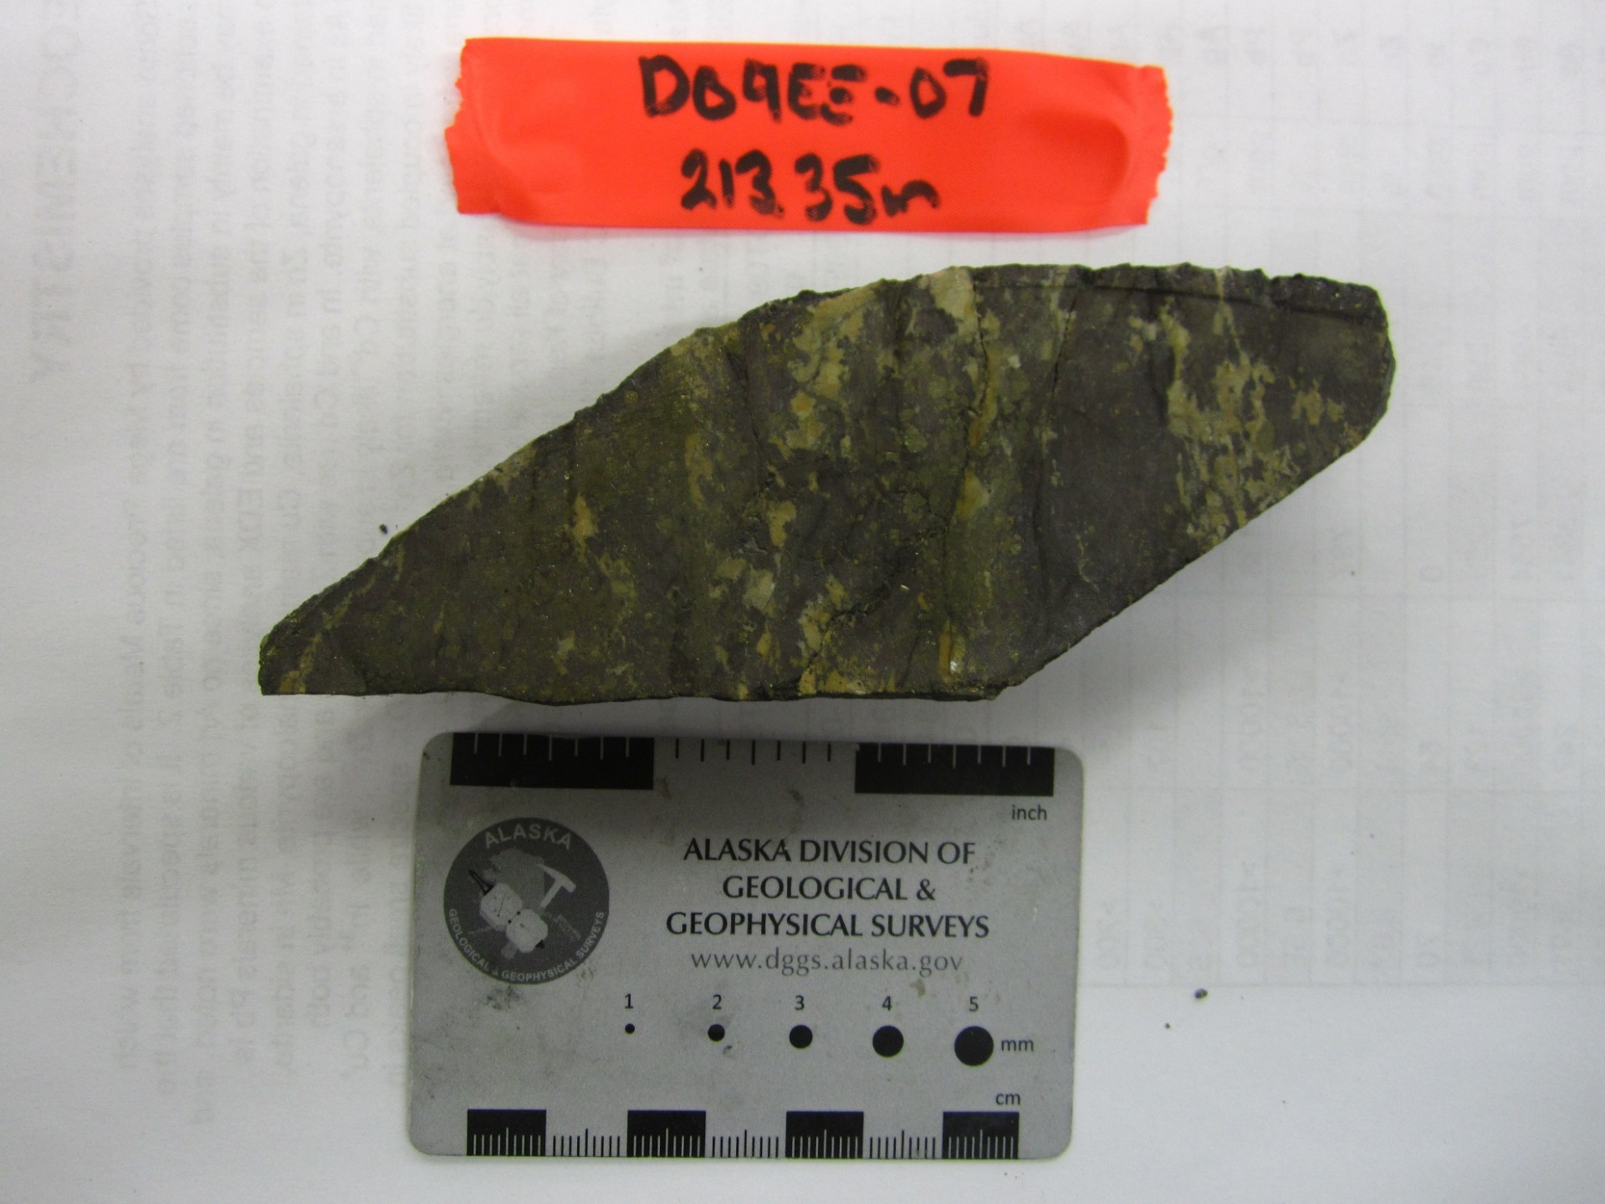
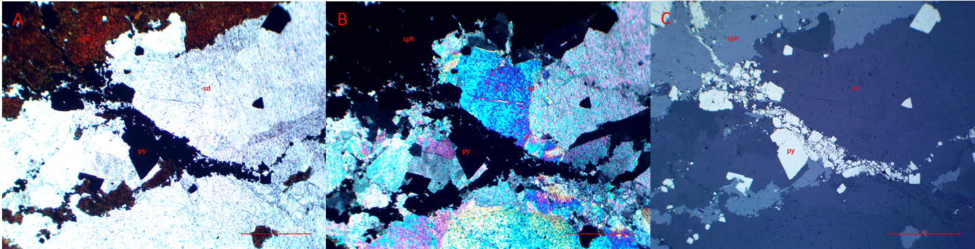
Figure 1 : Photomicrographs in (A) plane polarized, (B) cross polarized, and (C) reflected light of siderite cut by later sphalerite. Pyrite overprints sphalerite. Red scale bar 500µm.

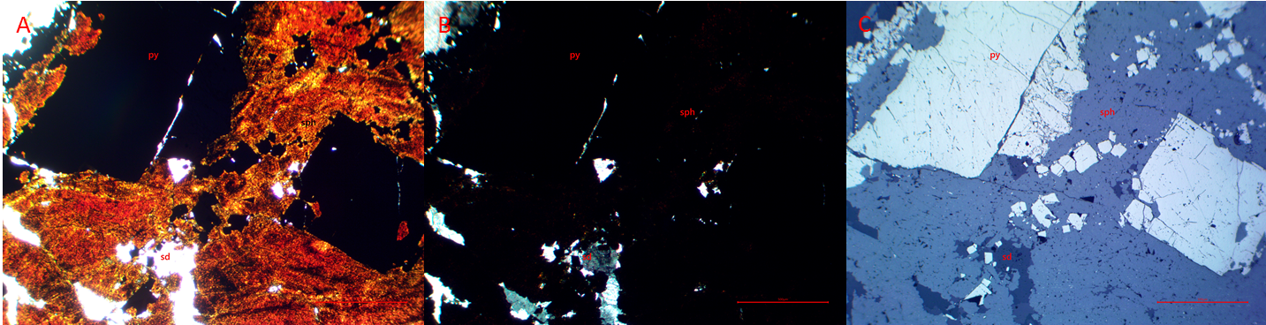
Figure 2 : Photomicrographs in (A) plane polarized, (B) cross polarized, and (C) reflected light of early sphalerite with clasts of siderite. Pyrite overprints sphalerite. Red scale bar 500µm.
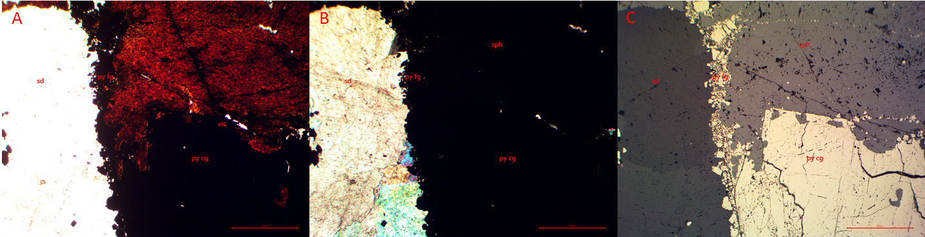
Figure 3 : Photomicrographs in (A) plane polarized, (B) cross polarized, and (C) reflected light of the contact between early siderite and sphalerite. Fine grain pyrite on contact and coarse grain pyrite overprints sphalerite. Red scale bar 500µm.

Hole: D09EE11 Depth: 254.10m Assay #: 075937 Vein: Eagle

Ag (ppm) | Au (ppm) | Pb (ppm) | Zn (ppm) | As (ppm) | Cd (ppm)
269 | 0.151 | 20000 | 52000 | 1633 | 727.6

Macroscopic description of sample:
There is early quartz with later siderite within a fault breccia. Some of the matrix contains pyrite. 254.0-254.15m is banded sphalerite-pyrite-chalcopyrite-siderite + pyrrhotite (?), where the upper contain is not visible (start of run) and the lower contact is sharp with fault gouge (@50°). The thin sections sample is banded sphalerite+pyrite+siderite+chalcopyrite+pyrrhotite(?). Fault gouge as lower contact.

Mineral | Modal % | Mineral Observations and Textures
Siderite | 15 | Clasts of siderite within bands of mineralization (2,3). Medium to coarse grain siderite with high birefringeance, rhombohedral grains that are euhedral to subhedral. Cut by sparse later fine grain siderite brecciating coarse grain siderite (2).
Quartz | 5 | Clasts of quartz within bands of sphalerite-pyrite. Quartz grains are fine to medium grain with wavy to indistinct grain boundaries, undulatory extinction, and low birefringeance (1). Some very fine grain recrystallized quartz grains within the clasts with distinct boundaries forming a netting over earlier quartz.
Sphalerite | 25 | Red-orange to darker brown-orange sphalerite banded with the sulphides (1-4). Moderately to heavily fractured. Contains clasts of quartz and siderite. Can be brecciated into clasts by galena and pyrite.
Pyrite | 52 | Fine to medium grain very corroded subhedral pyrite forms in bands and preferentially overprints galena, but also sphalerite, quartz, and siderite (3,5). The pyrite that is overprinting galena is more corroded than those in other areas. Grains can be melded together. This pyrite appears as the more yellow pyrite in hand sample. Another band of pyrite is medium to coarse grain, weakly corroded, and euhedral overprinting previous mineralization (4). This appears to be the more silver pyrite in hand sample. Late breccia fractures the banded pyrite into fragments (5).
Galena | 3 | Fills empty spaces in matrix of breccia (1,3) and is typically overprinted by fine grain corroded subhedral pyrite (3). Forms preferentially between siderite grains.

Textures and Cross-Cutting relationships:
Qtz<sd cg<sd fg<sph<gn<py<fractures

Paragenesis and Hantelmann’s 2013 Scheme
 | Stage description | Jos’ Paragenesis Level
 | Quartz | 1?
 | Coarse grain siderite | 2
 | Fine grain siderite | 6
 | Sphalerite | 7
 | Galena | 8a
 | Pyrite | 7a/b?
 | Fracturing

Photos:

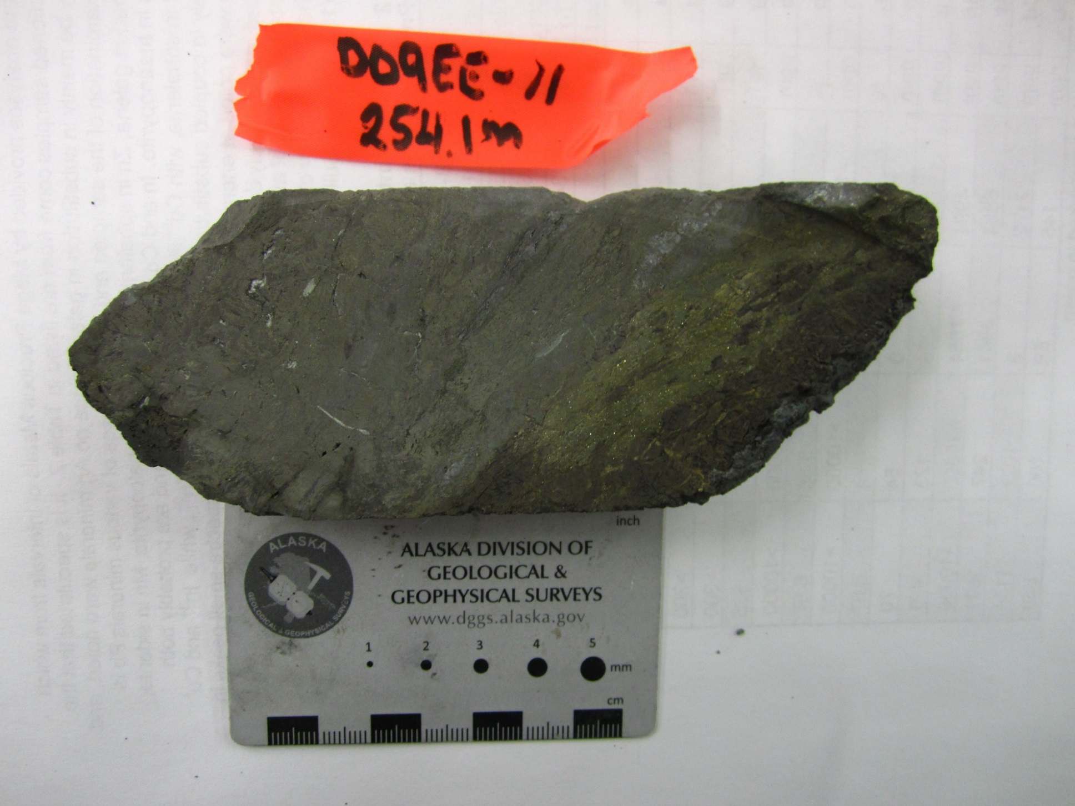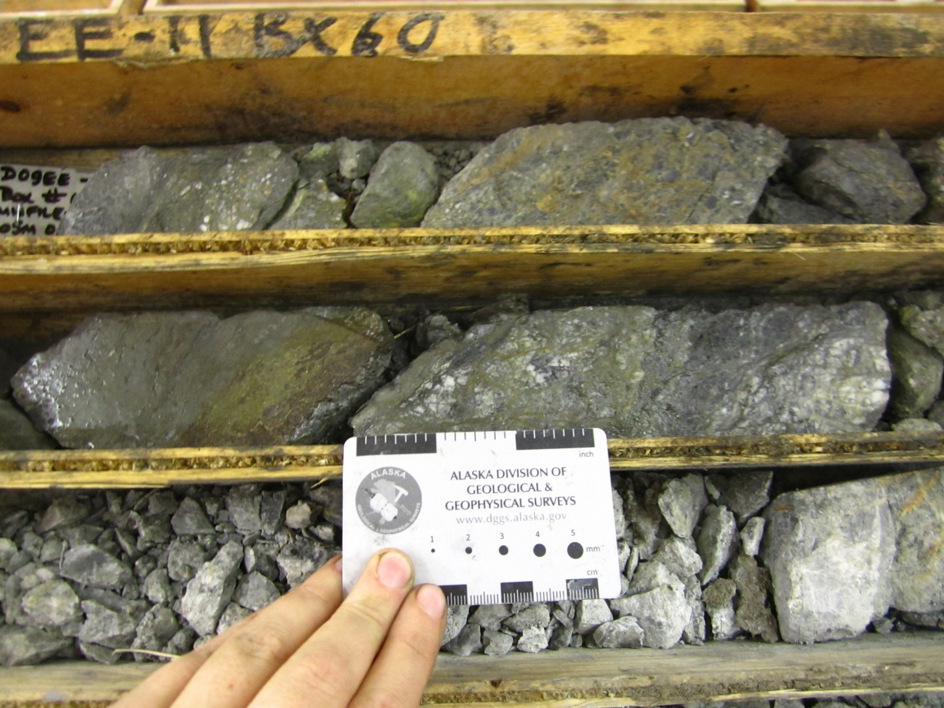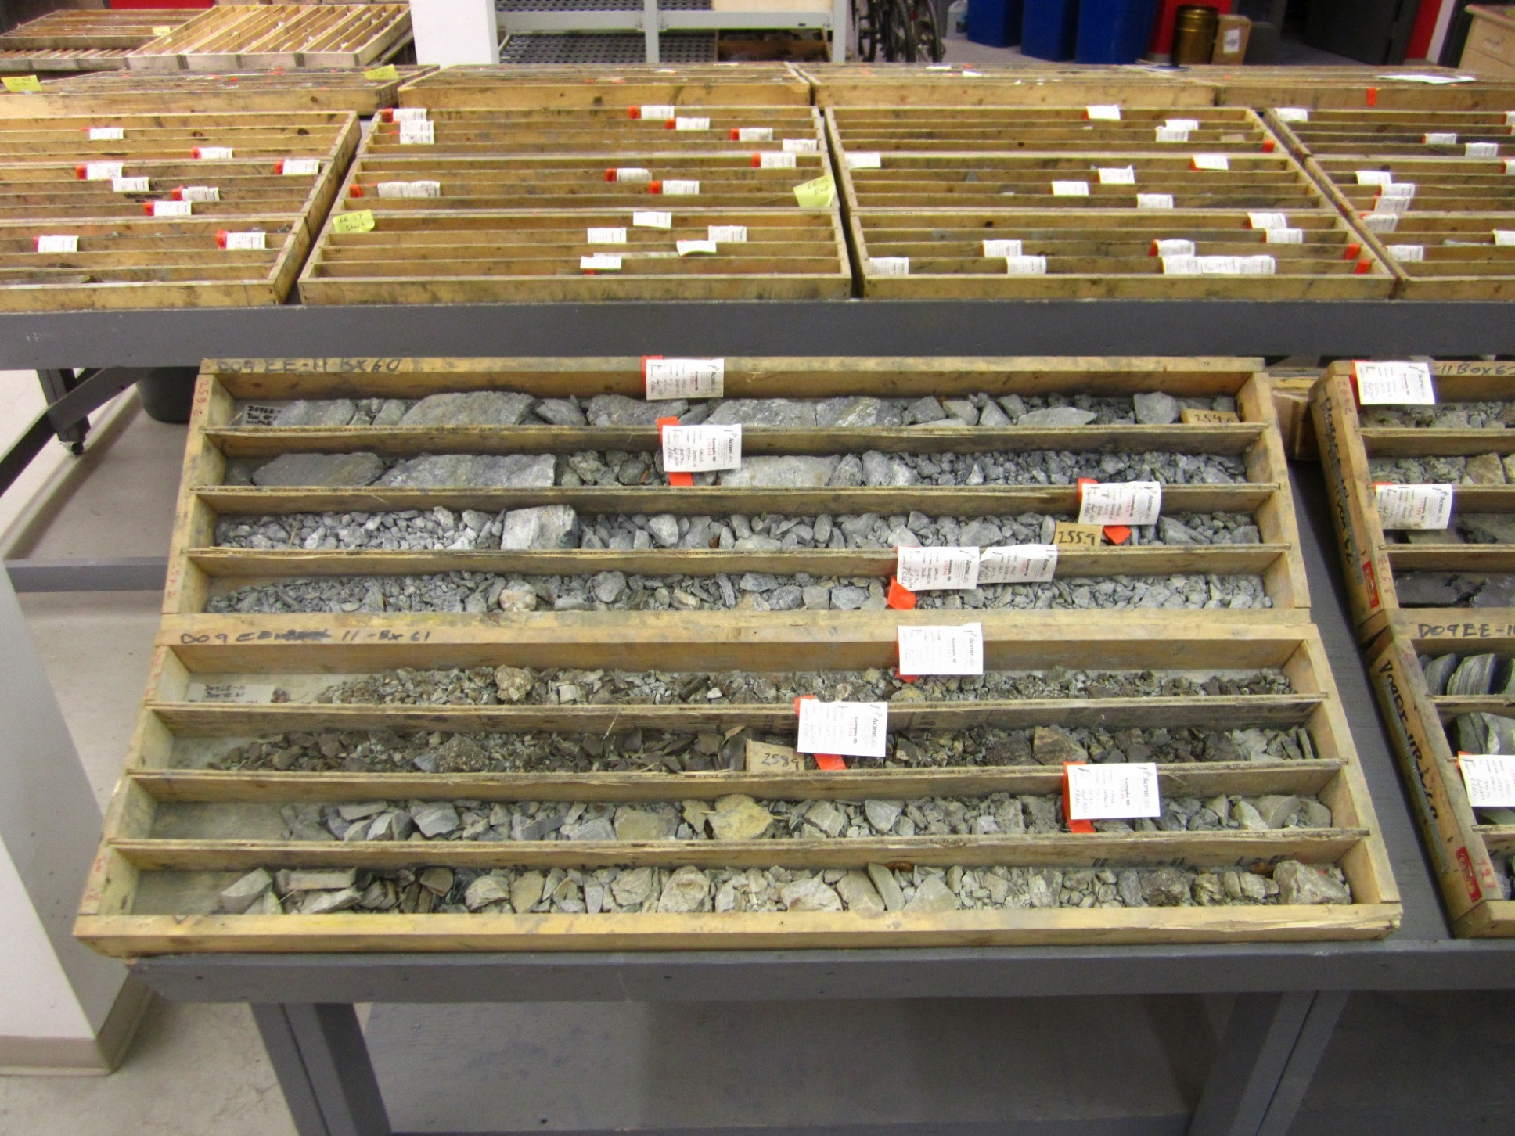
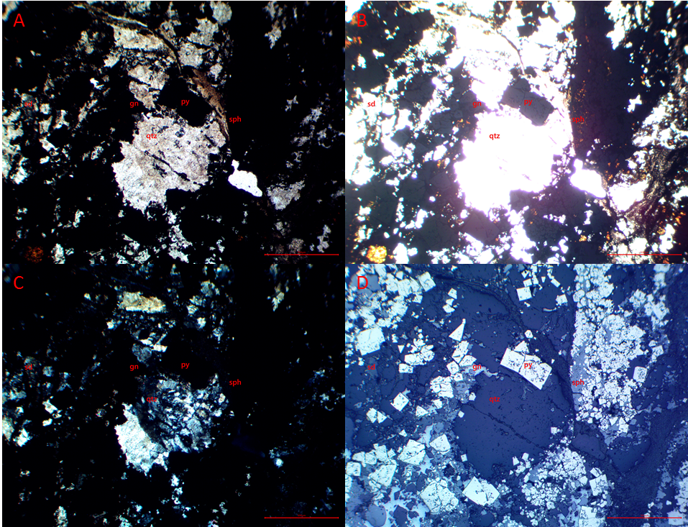
Figure 1 : Photomicrographs in (A) plane polarized, (B) bright plane polarized, (C) cross polarized, and (D) reflected light of a fault breccia with clasts of quartz and siderite. Matrix is filled with sphalerite and later galena with overprinting pyrite. Red scale bar 500µm.
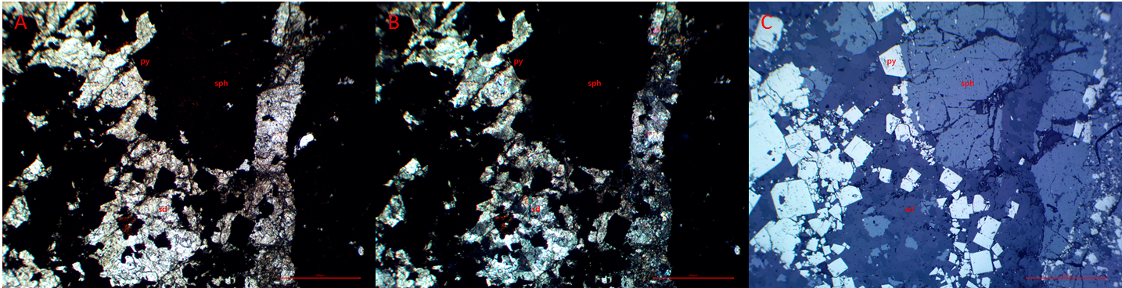
Figure 2 : Photomicrographs in (A) plane polarized, (B) cross polarized, and (C) reflected light of early fine grain siderite cut by later sphalerite in bands. Pyrite clusters in bands parallel to sphalerite. Red scale bar 500µm.

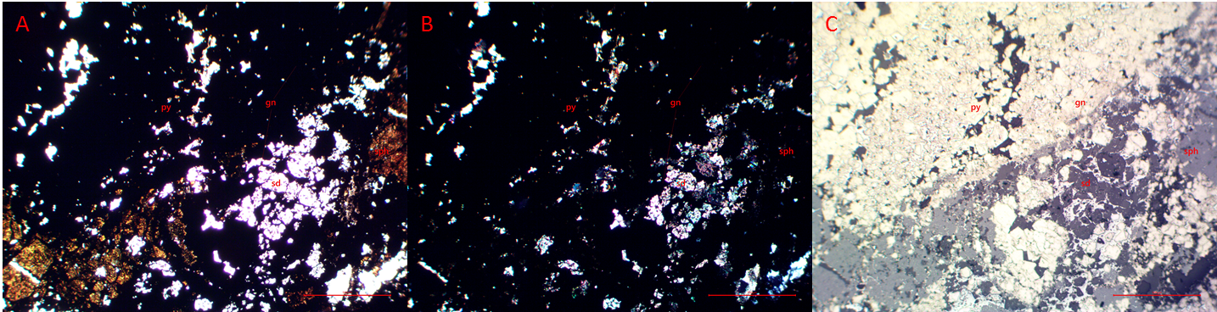
Figure 3 : Photomicrographs in (A) plane polarized, (B) cross polarized, and (C) reflected light of early siderite and sphalerite. This is cut by later galena heavily overprinted by pyrite. Red scale bar 500µm.
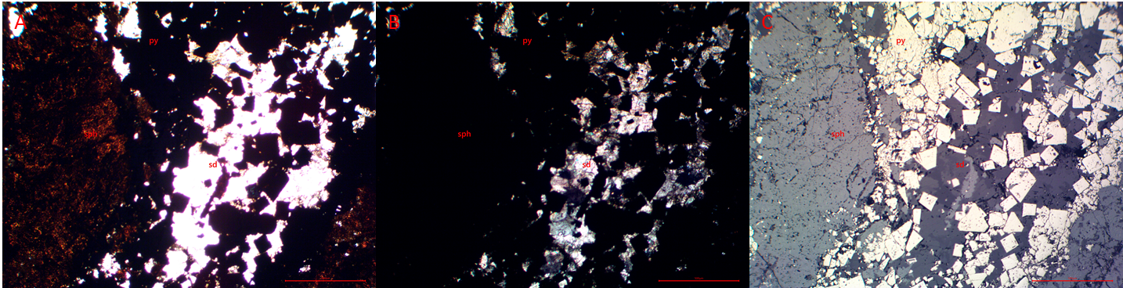
Figure 4 : Photomicrographs in (A) plane polarized, (B) cross polarized, and (C) reflected light of early siderite cut by sphalerite in bands. Pyrite overprints earlier mineralization, preferentially pyrite, in bands. Red scale bar 500µm.

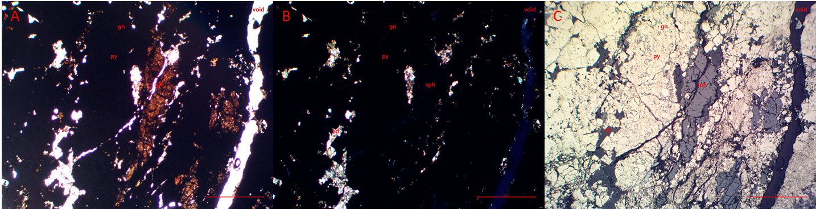
Figure 5 : Photomicrographs in (A) plane polarized, (B) cross polarized, and (C) reflected light of banded mineralization. Melded pyrite overprinting galena with elongated clasts of sphalerite. Red scale bar 500µm.

Hole: D09EE11 Depth: 254.15m Assay #: 075937 Vein: Eagle

Ag (ppm) | Au (ppm) | Pb (ppm) | Zn (ppm) | As (ppm) | Cd (ppm)
269 | 0.151 | 20000 | 52000 | 1633 | 727.6

Macroscopic description of sample:
There is early quartz with later siderite within a fault breccia. Some of the matrix contains pyrite. The thin sections sample is early quartz, later netting of siderite. This is microfractured with weak fill of fine grain pyrite. Upper contact is fault gouge, as in sample 254.1m.

Mineral | Modal % | Mineral Observations and Textures
Quartz | 70 | Quartz grains are fine to medium grain with wavy to indistinct grain boundaries, undulatory extinction, and low birefringeance. Abundant very fine grain recrystallized quartz grains within the clasts with distinct boundaries forming a netting through non-recrystallized quartz (2).
Siderite | 9 | Netting of stringers of siderite cutting through quartz. Microscopically seen to be fragments and clasts of medium grain siderite in matrix of very fine to ground siderite (1).
Sphalerite | 1 | Small grains only within very fine grain siderite matrix (1,3). Orange-brown.
Pyrite | 20 | Fine to medium grain very corroded subhedral pyrite forms in clusters and preferentially in siderite breccias (1). Grains can be melded together. Late breccia fractures the banded pyrite into fragments (3).

Textures and Cross-Cutting relationships:
Qtz<cg sd<fg sd-bx<sph<py<fract

Paragenesis and Hantelmann’s 2013 Scheme
 | Stage description | Jos’ Paragenesis Level
 | Quartz | 1?
 | Coarse grain siderite | 2
 | Fine grain siderite breccia | 6
 | Sphalerite in fg bx | 7
 | Melded pyrite | 7a/b?
 | Fractures | ?

Photos:
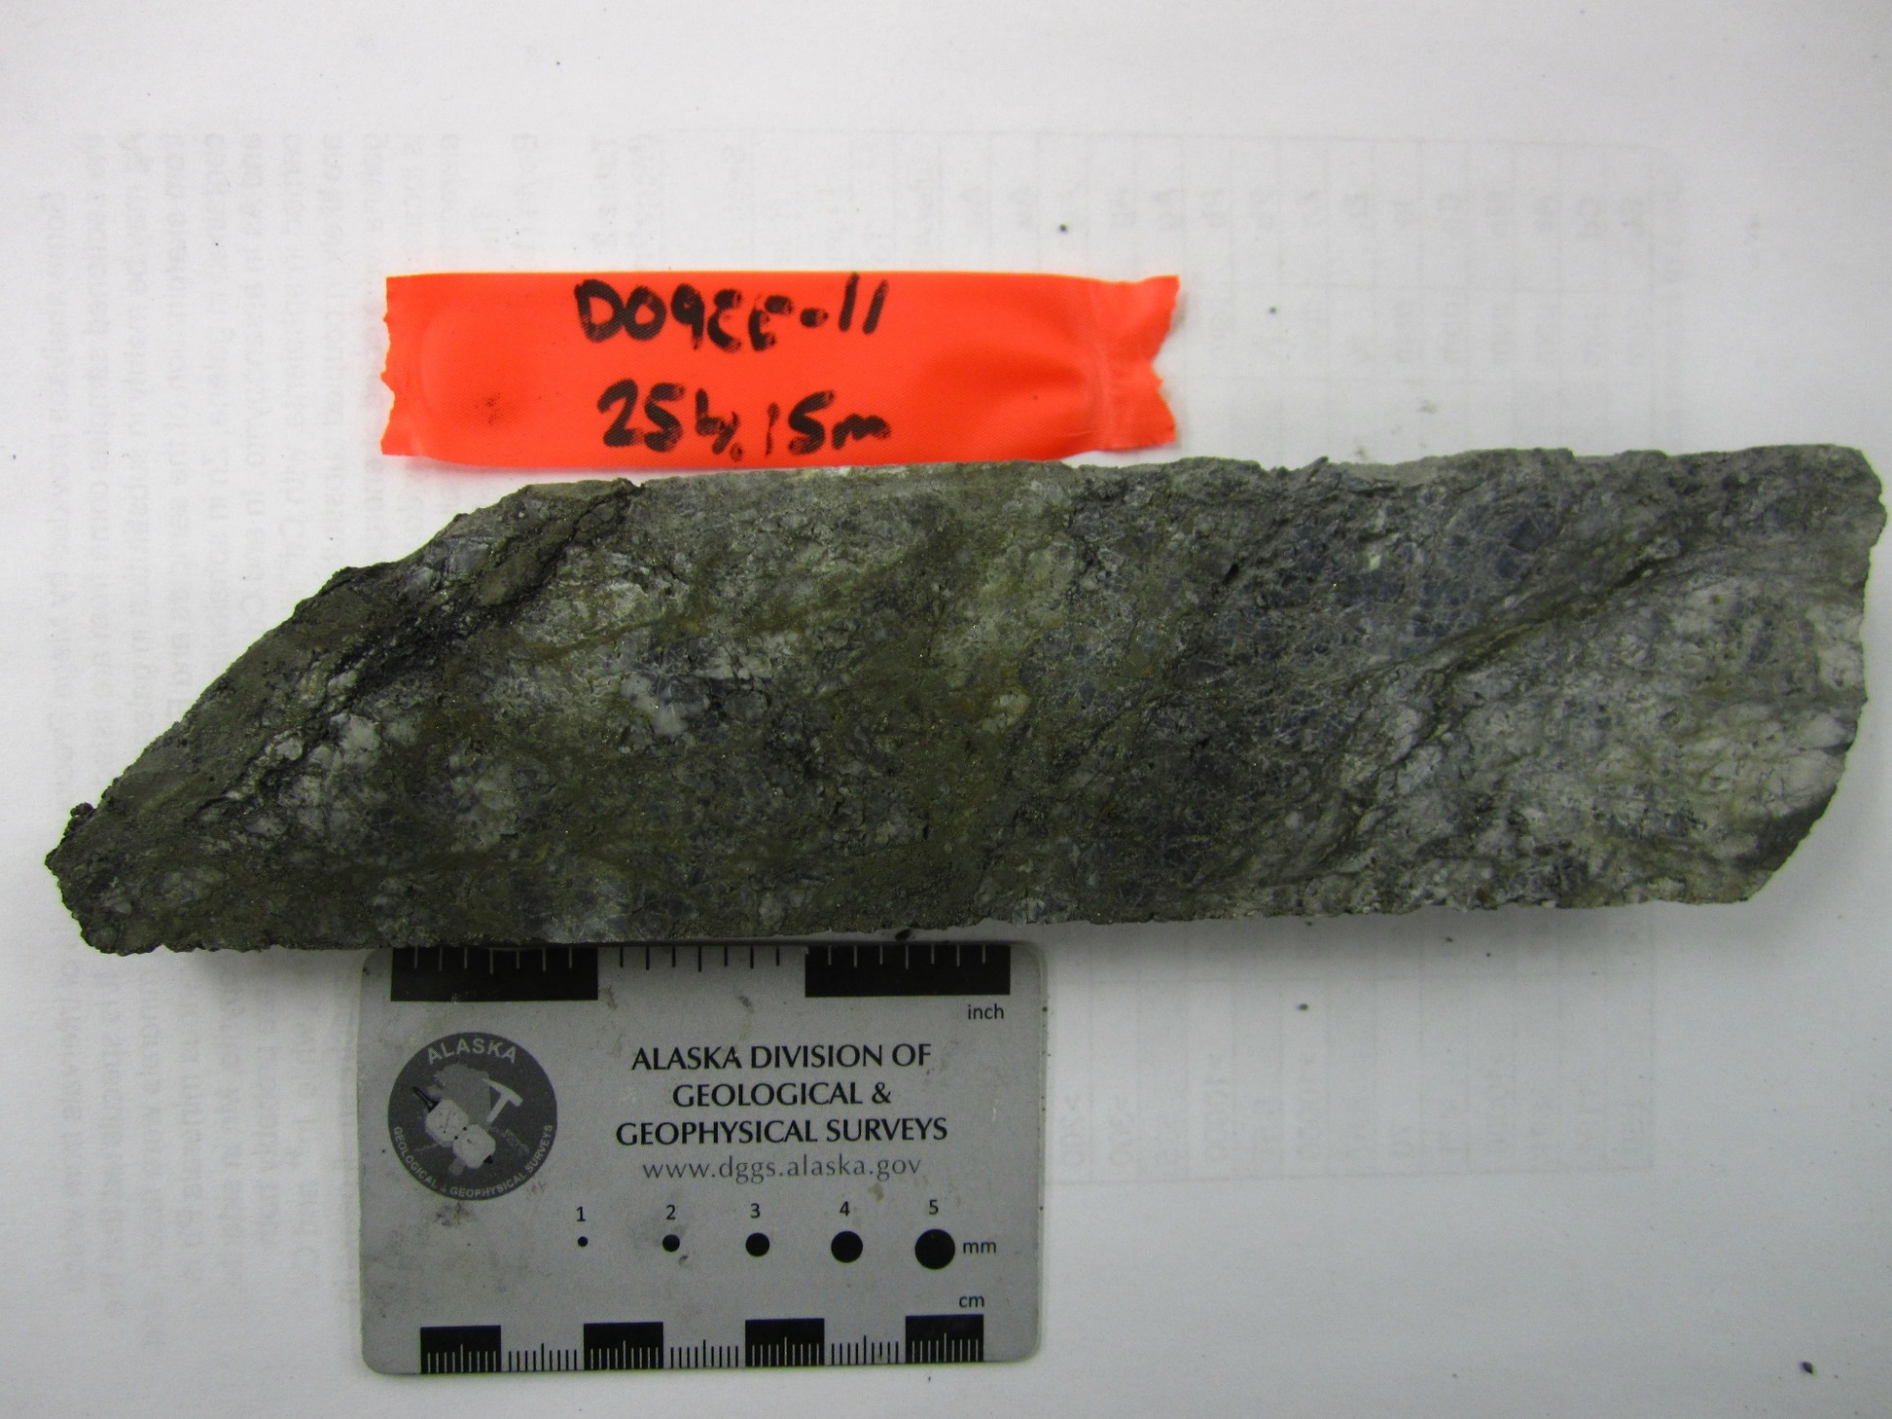
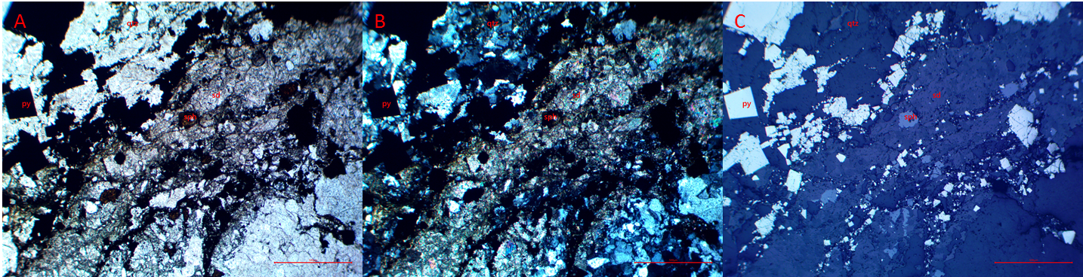
Figure 1 : Photomicrographs in (A) plane polarized, (B) cross polarized, and (C) reflected light of quartz cut by brecciating fine grain siderite. Sphalerite fills empty spaces in siderite. Overprinted by very fine to coarse grain siderite. Red scale bar 500µm.

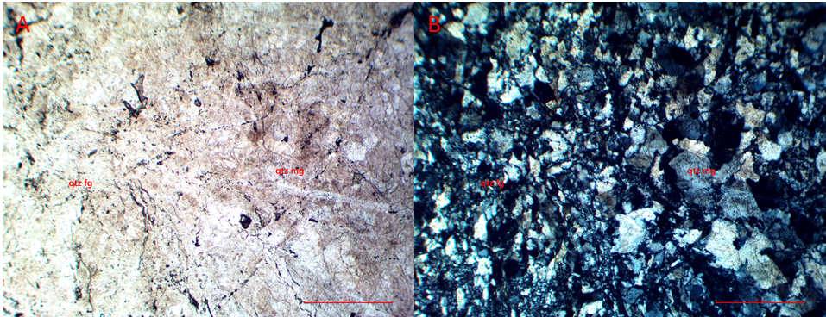
Figure 2 : Photomicrographs in (A) plane and (B) cross polarized light of medium grain quartz overprinted by fine grain quartz. Red scale bar 500µm.
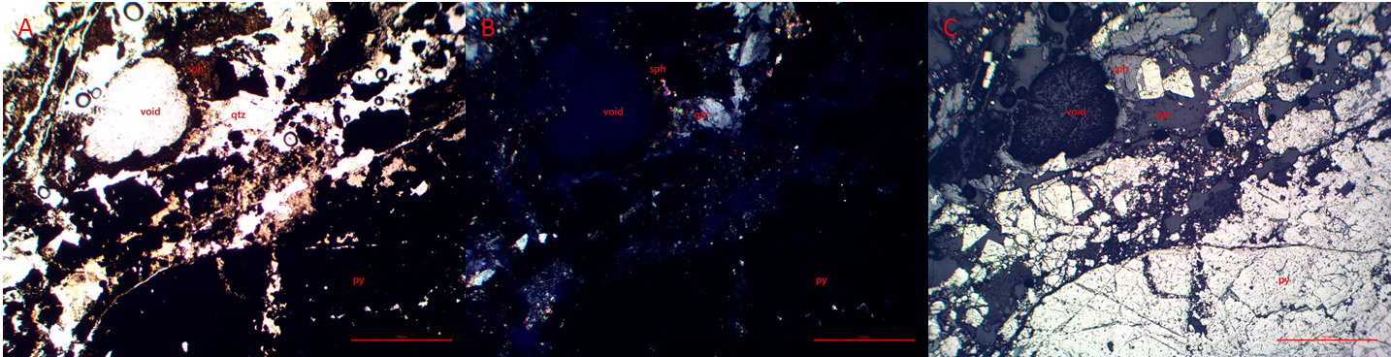
Figure 3 : Photomicrographs in (A) plane polarized, (B) cross polarized, and (C) reflected light of brecciated melded pyrite. Sphalerite, and quartz also within the brecciation zone. Red scale bar 500µm.
Hole: D09EE11 Depth: 263.40m Assay #: 075949 Vein: Eagle

Ag (ppm) | Au (ppm) | Pb (ppm) | Zn (ppm) | As (ppm) | Cd (ppm)
43.7 | 0.228 | 1228 | 136200 | 3125 | 1742

Macroscopic description of sample:
Early quartz veinlets cut by later sphalerite+galena+minor siderite. Late coarse grain pyrite. Thin section has early sphalerite+galena cut by later siderite and overprinted by late coarse grain pyrite.

Mineral | Modal % | Mineral Observations and Textures
Siderite | 3 | Medium to coarse grain siderite with high birefringeance, rhombohedral grains that are euhedral to subhedral (3). Cut by sparse later fine grain siderite brecciating coarser grain siderite (1).
Sphalerite | 30 | Blood red sphalerite cuts and includes clasts of earlier phases of siderite (2,3). Some fracturing. Cut by later pyrite. Smaller grains can be preferentially seen within fine grain siderite (1).
Pyrite | 66.5 | Coarse to very coarse grain euhedral to subhedral pyrite cuts and has small clasts of sphalerite and siderite. Fractured moderately to heavily (2,3). Grains are occasionally melded together.
Arsenopyrite | 0.1 | Sparse elongated clusters along one plane of medium grain fractured subhedral Arsenopyrite. Grey-light grey in reflected light (3).
Chalcopyrite | 0.5 | Small abundant flecks of yellow-gold chalcopyrite in sphalerite (2,3).

Textures and Cross-Cutting relationships:
Cg sd<fg Sd<sph-cpy<py(-apy?)

Paragenesis and Hantelmann’s 2013 Scheme
 | Stage description | Jos’ Paragenesis Level
 | Coarse grain siderite | 2
 | Fine grain siderite | 6
 | Sphalerite with flecks of chalcopyrite | 7
 | Pyrite(-arsenopyrite?) | 7a/b?

Photos:
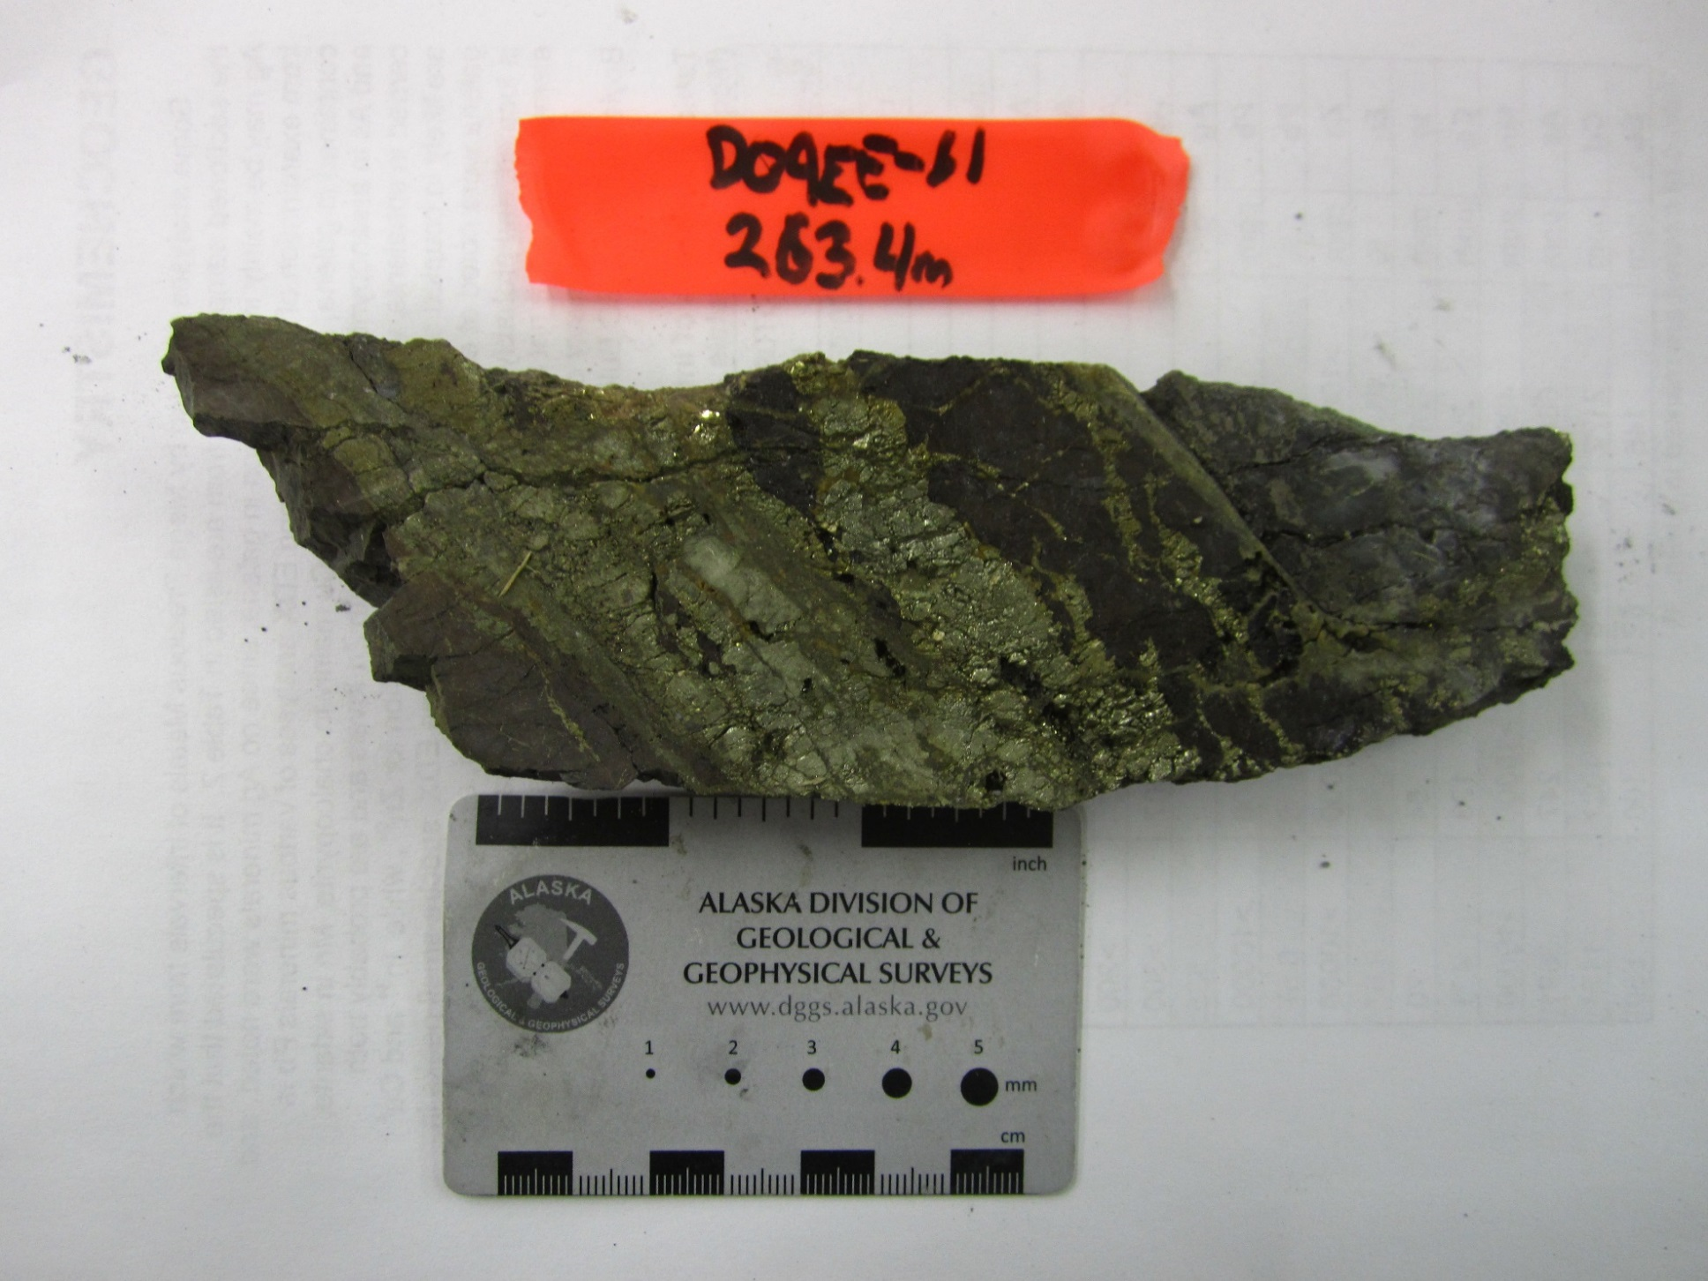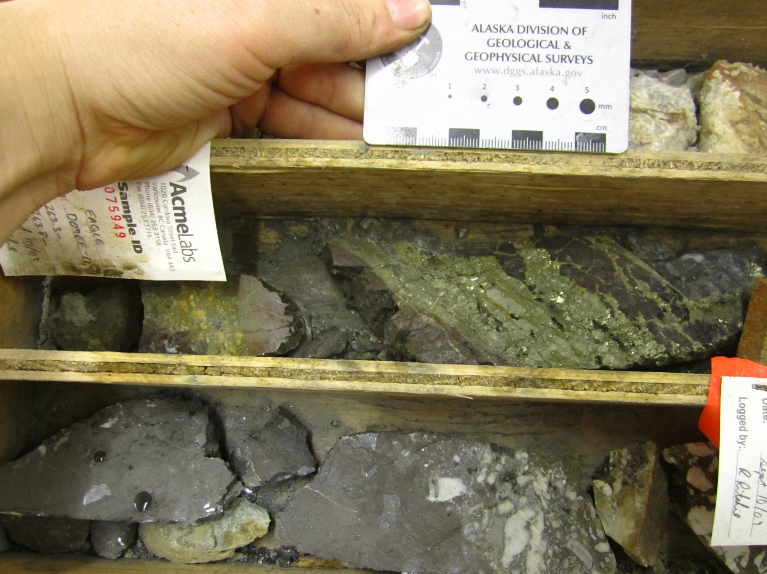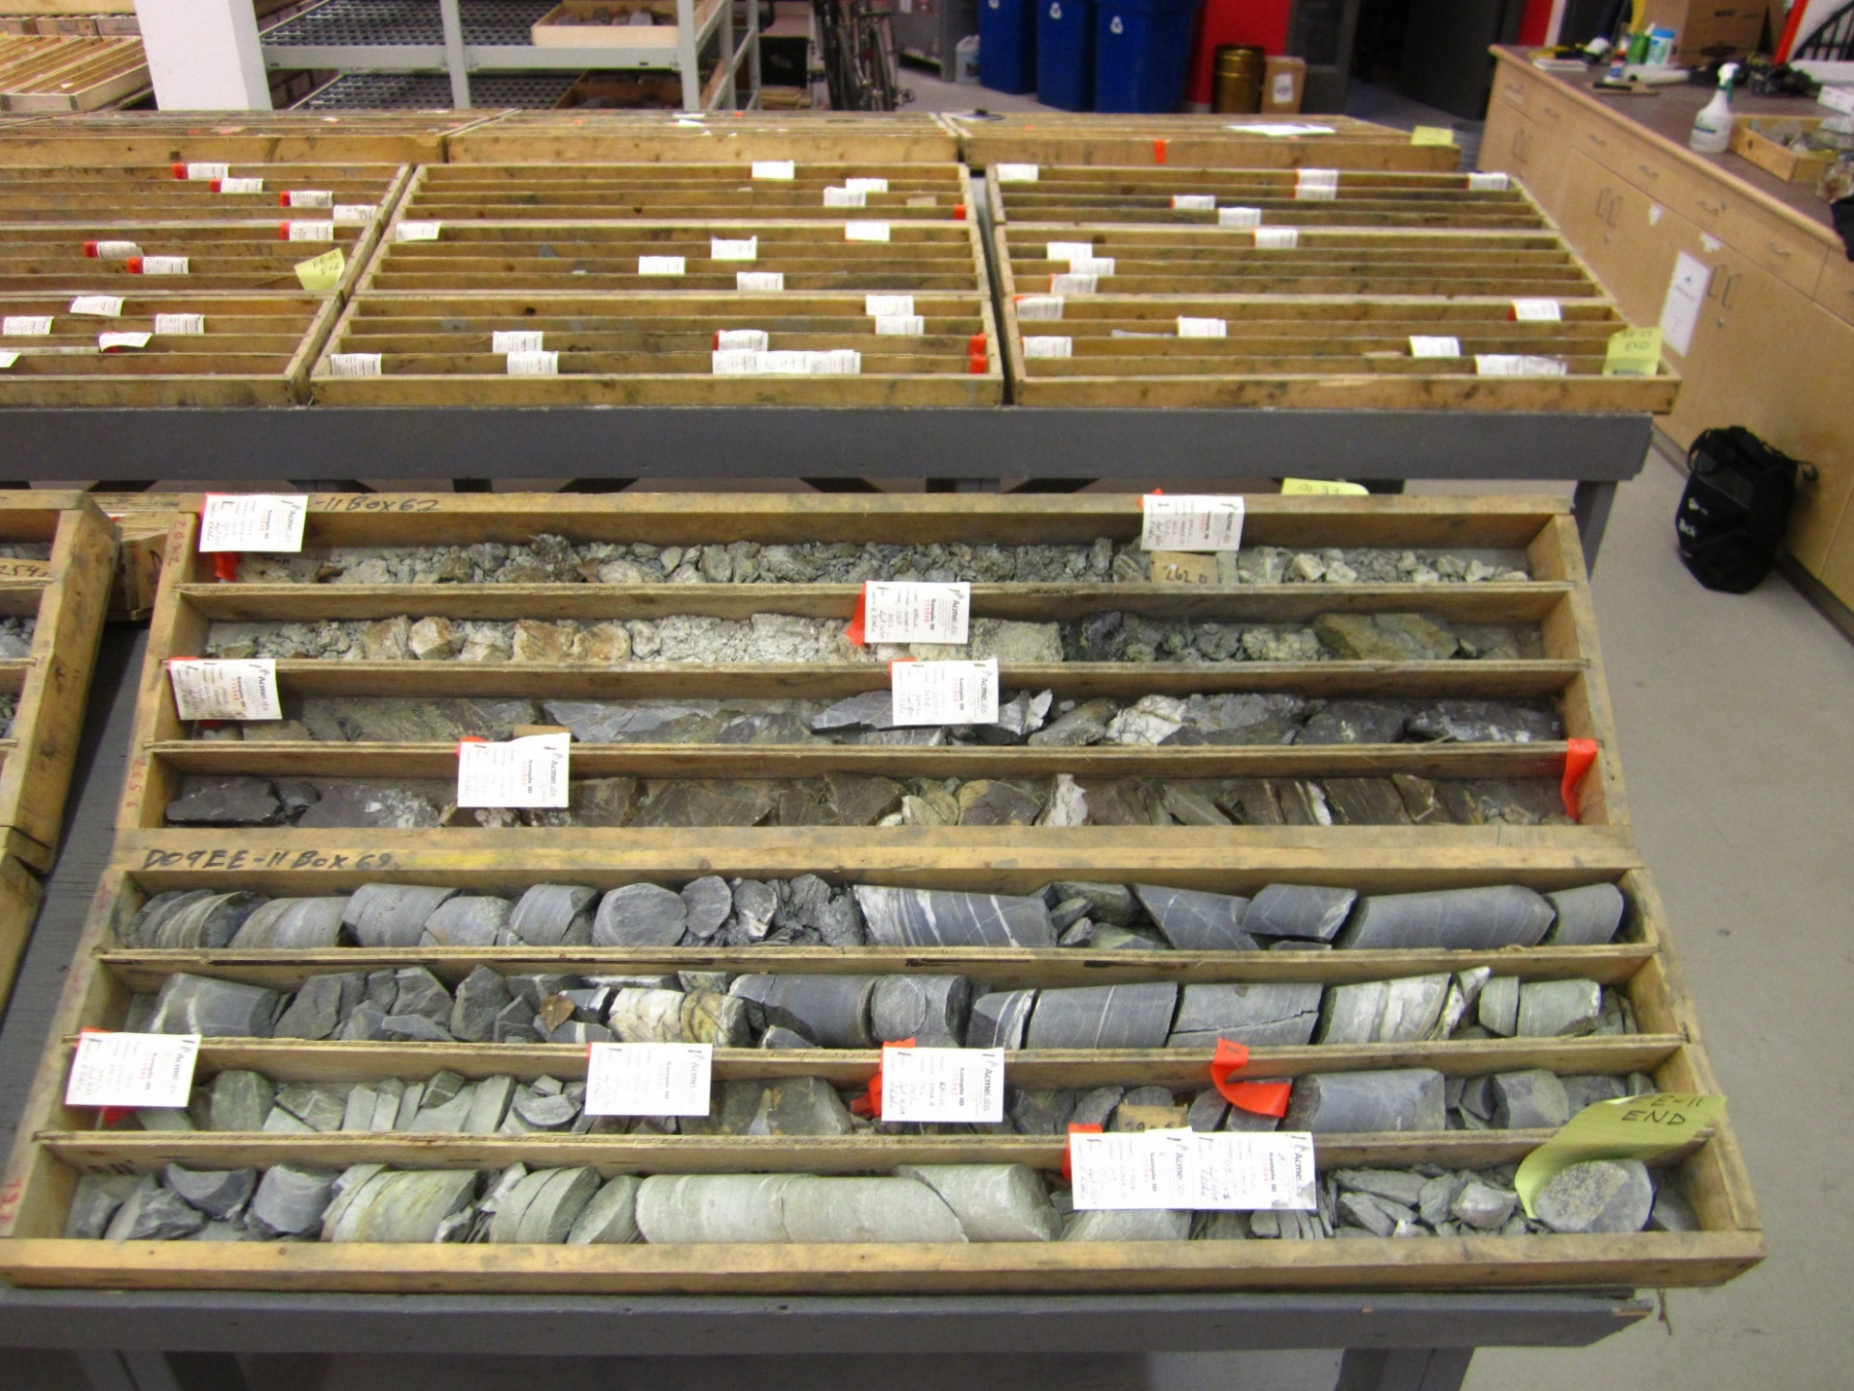
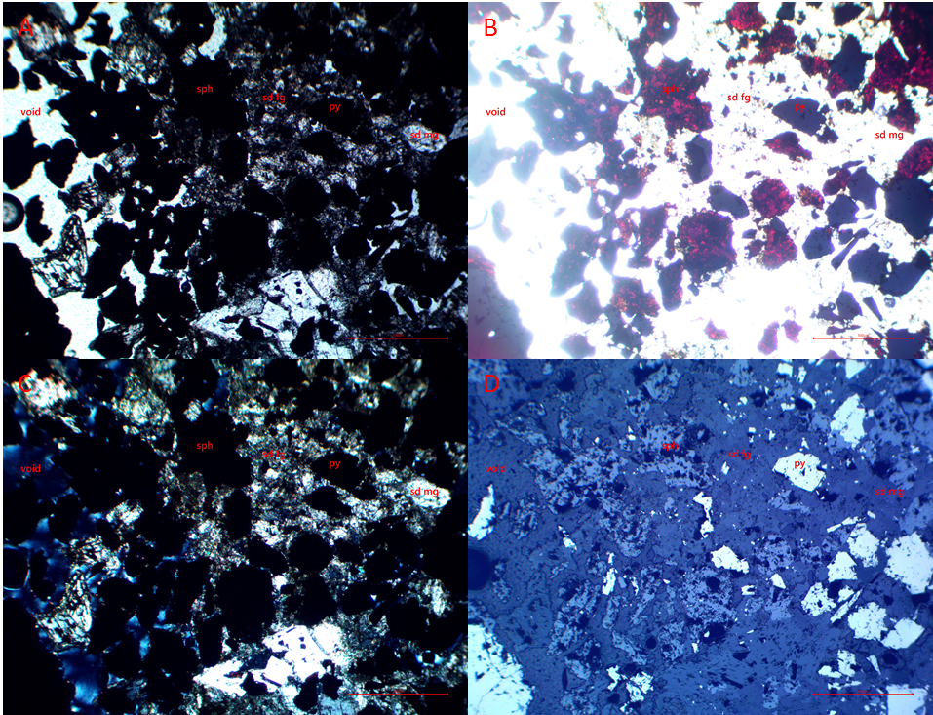
Figure 1 : Photomicrographs in (A) plane polarized, (B) bright plane polarized, (C) cross polarized, and (D) reflected light of a breccia zone of fine grain siderite, sphalerite, and pyrite. Red scale bar 500µm.
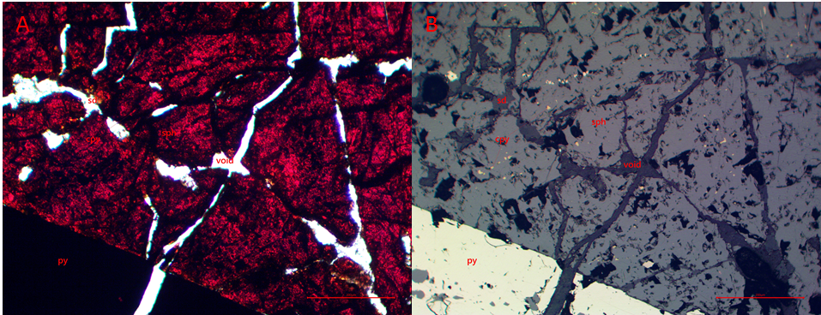
Figure 2 : Photomicrographs in (A) plane polarized, and (B) reflected light of fractured sphalerite with flecks of chalcopyrite with overprinting pyrite. Fractures cut through siderite and pyrite. Red scale bar 200µm.

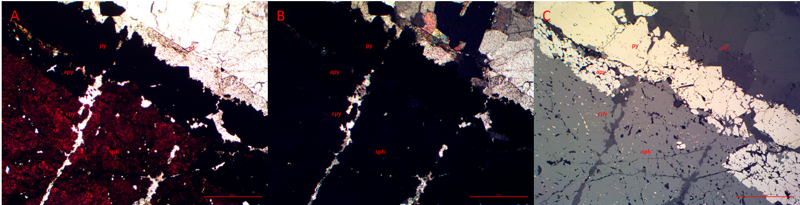
Figure 3 : Photomicrographs in (A) plane polarized, (B) cross polarized, and (C) reflected light of the contact between sphalerite with flecks of chalcopyrite and siderite. Melded strand of pyrite on the contact. Melded arsenopyrite strands also parallel to pyrite. Red scale bar 500µm.
Hole: D09EE11 Depth: 264.50m Assay #: 075950 Vein: Eagle

Ag (ppm) | Au (ppm) | Pb (ppm) | Zn (ppm) | As (ppm) | Cd (ppm)
21.4 | 0.337 | 276 | 266600 | 2275 | >4000

Macroscopic description of sample:
. Early quartz veinlets cut by later sphalerite+galena+minor siderite. Late coarse grain pyrite. Thin section has early brecciated fault healed quartz cut by later galena-sphalerite vein.

Mineral | Modal % | Mineral Observations and Textures
Quartz | 66 | Quartz veining is present as clasts within later mineralization of siderite, carbonate-muscovite, and sphalerite. Quartz is medium to coarse grain with wavy to indistinct grain boundaries, undulatory extinction, and low birefringeance (3,4). Sparse very fine grain recrystallized quartz grains within the clasts with distinct boundaries forming a netting over earlier quartz. Veinlets of fine grain quartz with distinct wavy boundaries cut through earlier medium to coarse quartz (3).
Muscovite | 5 | Clear in plane-polarized light, high birefringeance in cross-polarized light, and darker than quartz in reflected light. Muscovite is intergrown with the red-orange carbonate in late-stage veinlets. It forms as sprays of sheets within the veinlets (1,3,4).
Siderite | 2 | Two phases of siderite. The first is coarse grain, euhedral, rhombohedral cross-hatching, high birefringeance (1). The second is a fine grain to ground siderite as a matrix of a fault breccia that cuts coarse grain siderite preferentially, but also quartz (less abundant).
Carbonate | 10 | Red-orange in ppl and xpl, same reflectivity as siderite. Very fine grain. Cuts through previous mineralization (quartz, siderite) and fault brecciation (fg siderite matrix) intergrown with muscovite in veinlets (1,3). Preferentially cuts through fine grain quartz stringers. Cut by later sphalerite (2,4).
Sphalerite | 15 | Blood red, weakly fractured (2). Has trace flecks of chalcopyrite. Cuts through previous mineralization of quartz, siderite, carbonate-muscovite, and pyrite. Past boundary of large vein, sphalerite preferentially forms in fault breccia matrix and in muscovite-carbonate veinlets (4).
Pyrite | 2 | Coarse to medium grain subhedral pyrite, weakly fractured, found in fault breccia (4).
Chalcopyrite | 0.05 | As flecks in sphalerite. Yellow-gold in reflected light, opaque in transmitted light (4).

Textures and Cross-Cutting relationships:
Qtz mg<cg sd<fg bx sd-py<qtz fg<car-musc<sph-cpy

Paragenesis and Hantelmann’s 2013 Scheme
 | Stage description | Jos’ Paragenesis Level
 | Medium grain quartz | 1
 | Coarse grain siderite | 2
 | Fine grain siderite flt bx – pyrite | 6 – 7a/b
 | Fine grain quartz | ?
 | Yellow-orange carbonate and sprays of muscovite | ?
 | Sphalerite-chalcopyrite | 7-8b?

Photos:
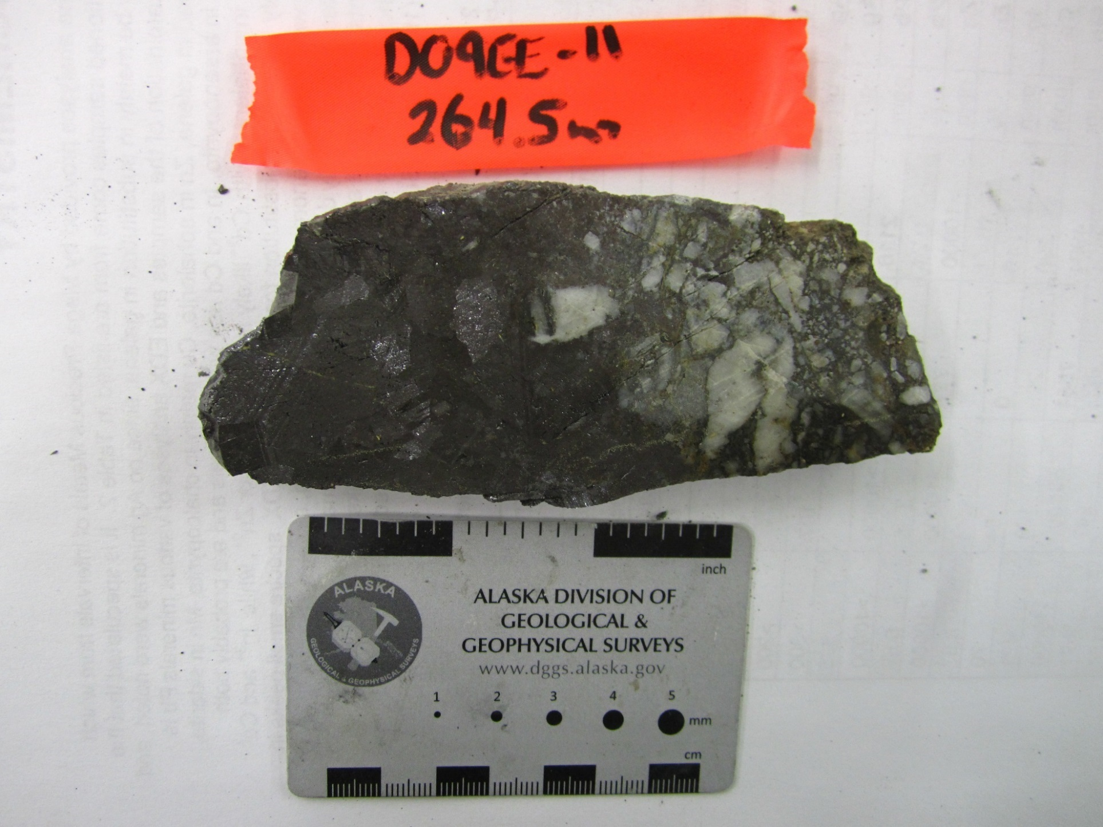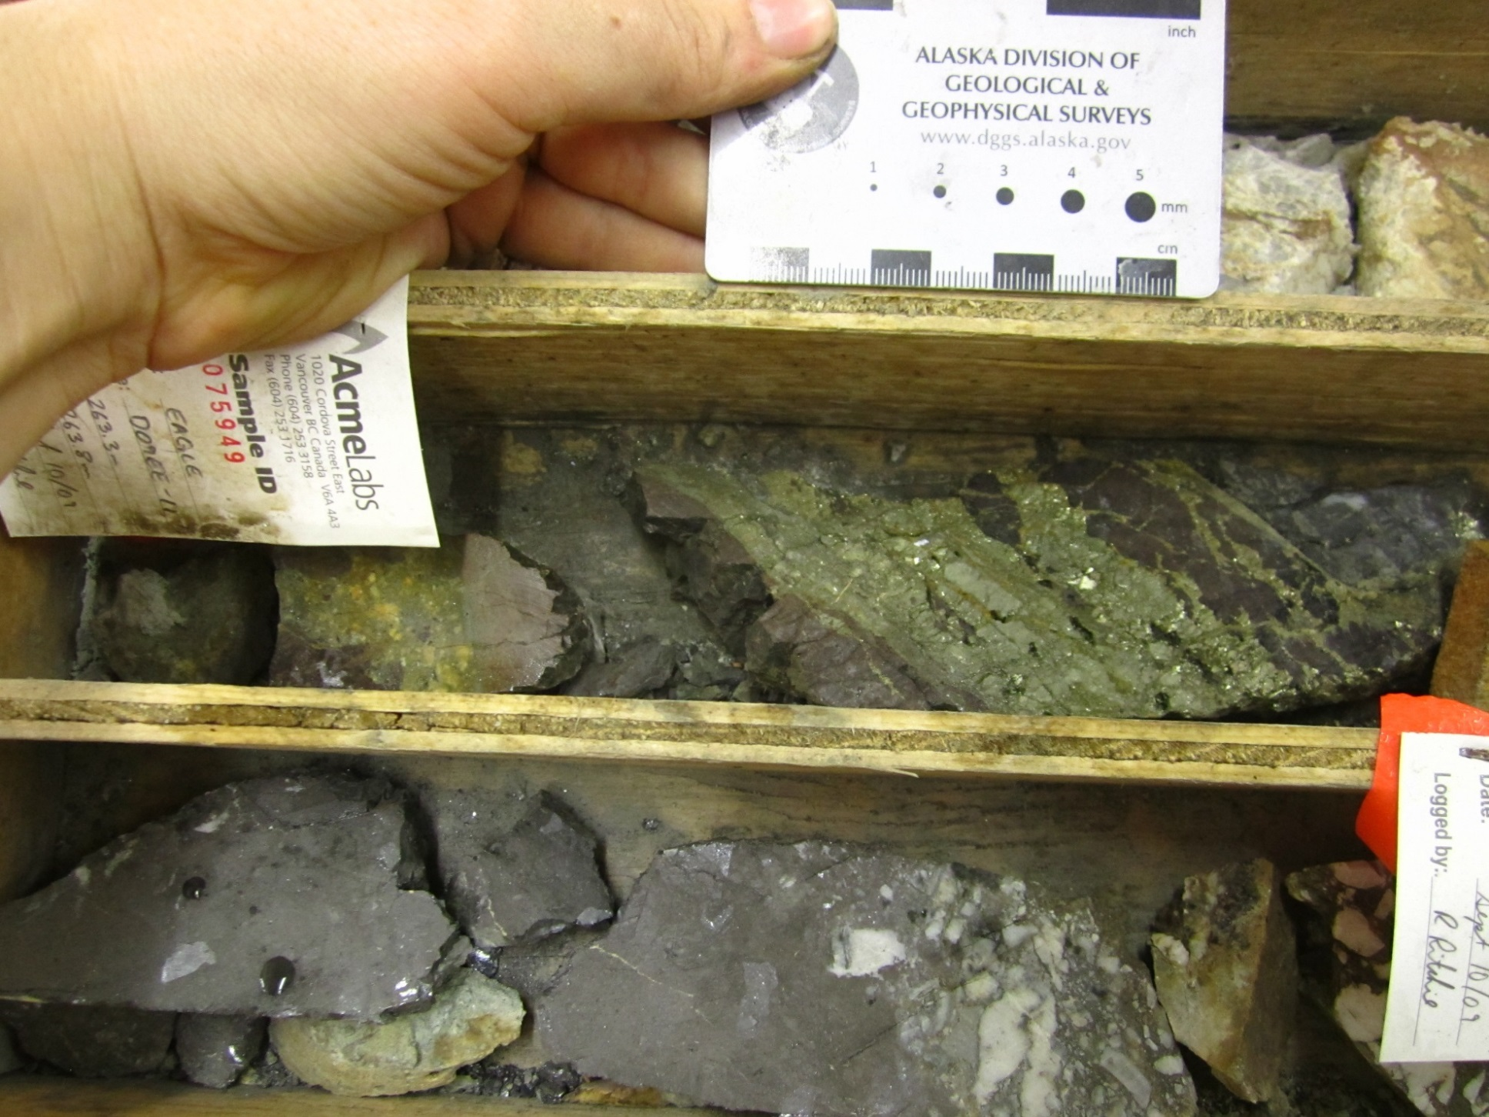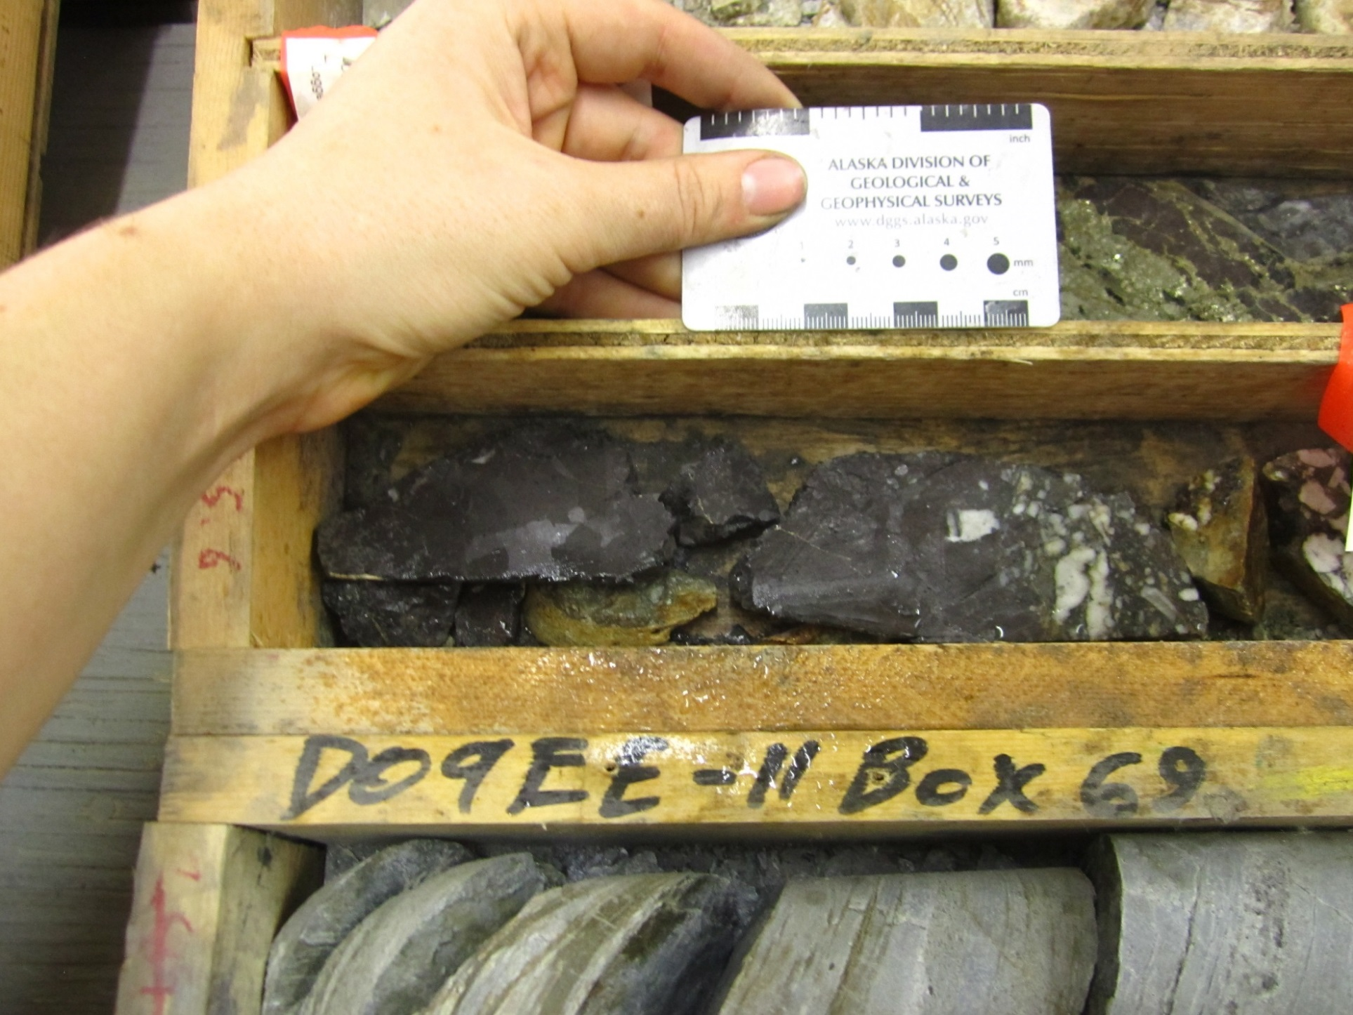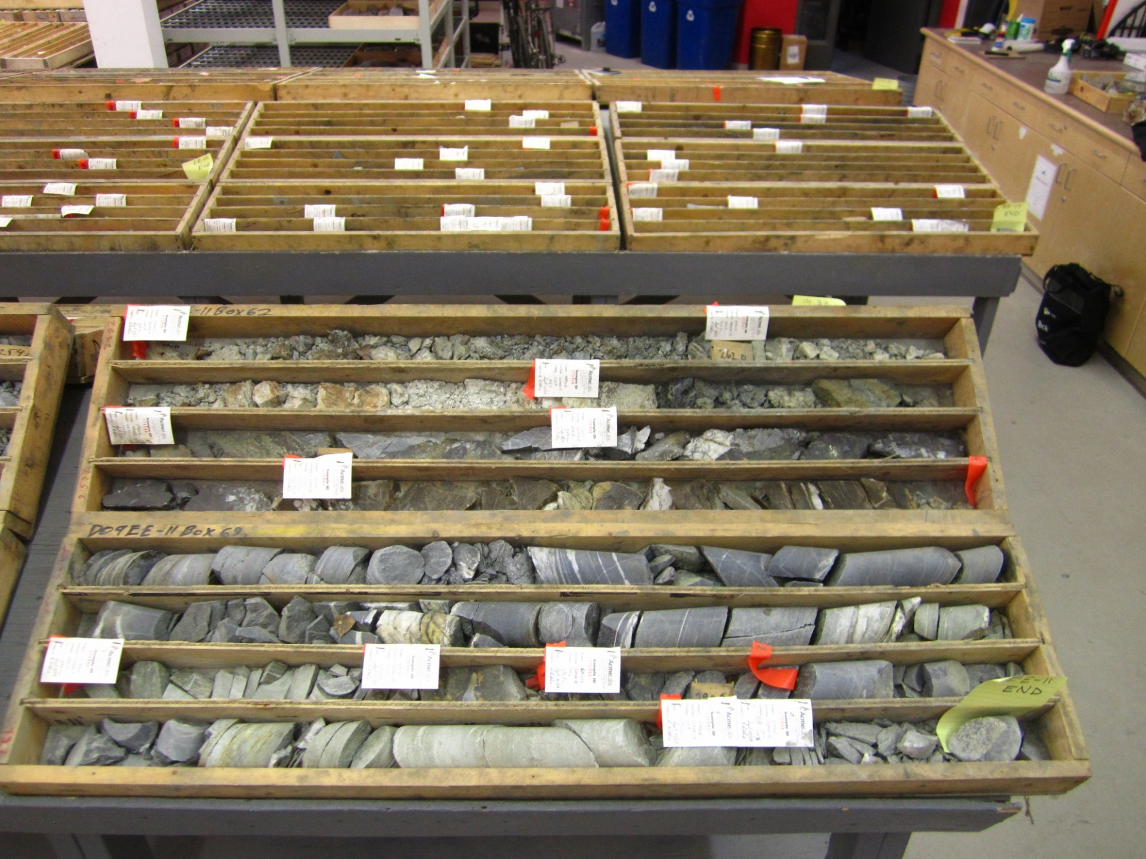
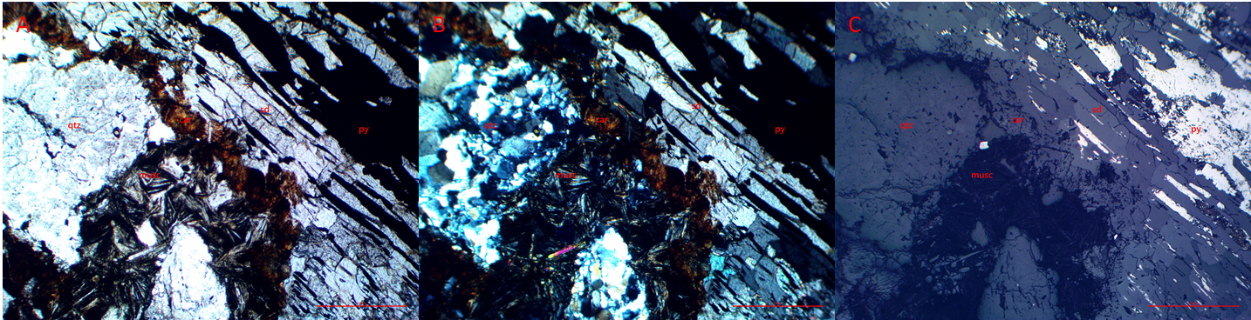
Figure 1 : Photomicrographs in (A) plane polarized, (B) cross polarized, and (C) reflected light of clasts of quartz in coarse grain siderite. Muscovite on contact between quartz and siderite. Elongated strands of pyrite overprinting siderite. Red scale bar 500µm.

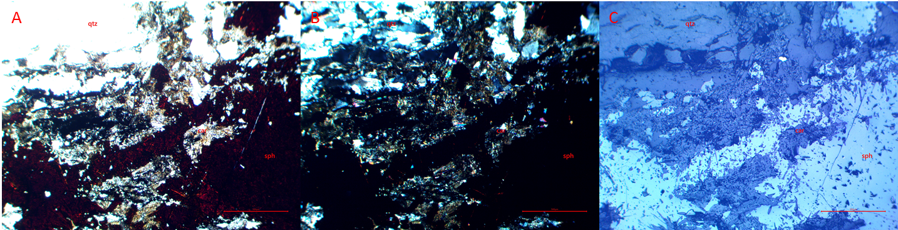
Figure 2 : Photomicrographs in (A) plane polarized, (B) cross polarized, and (C) reflected light of clasts of quartz in fine grain carbonate. Sphalerite fills empty spaces with prismatic clasts of carbonate. Red scale bar 500µm.

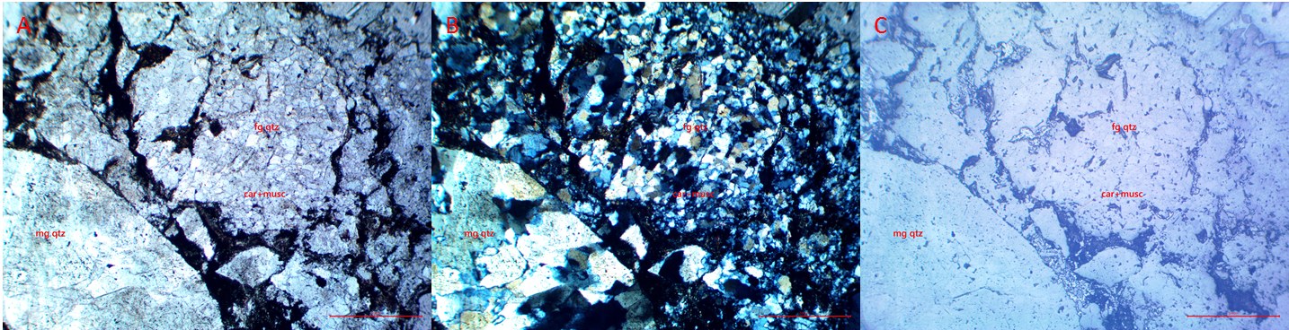
Figure 3 : Photomicrographs in (A) plane polarized, (B) cross polarized, and (C) reflected light of medium grain quartz cutting fine grain quartz with strands of carbonate and muscovite. Red scale bar 500µm.

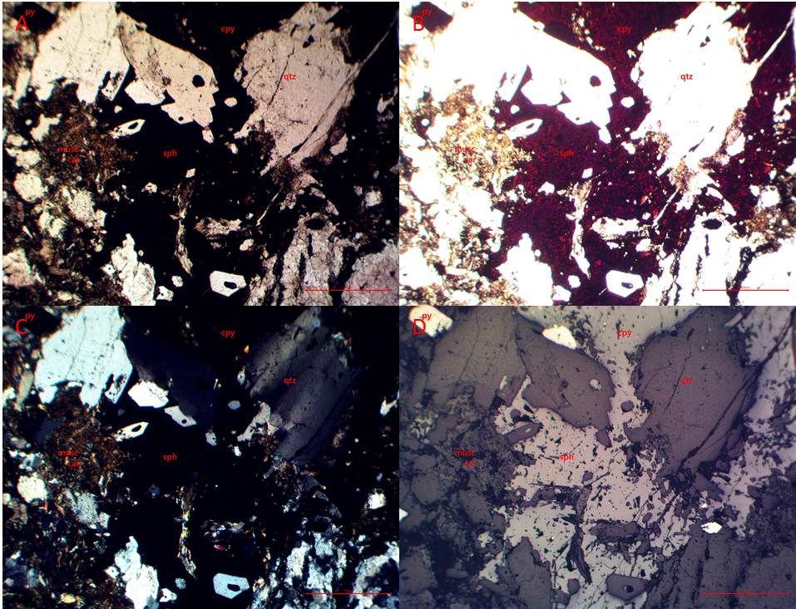
Figure 4 : Photomicrographs in (A) plane polarized, (B) bright plane polarized, (C) cross polarized, and (D) reflected light of clasts of quartz, and a mix of carbonate and muscovite in a sphalerite matrix. Sphalerite has flecks of chalcopyrite. Red scale bar 500µm.

