Section 1: Installing VPN Check Point
Step 1:
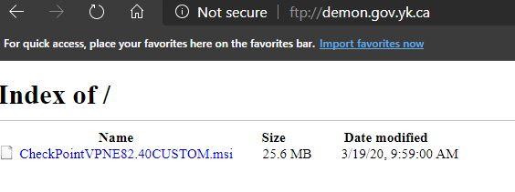
Open any web browser and go to website ftp://demon.gov.yk.ca click on CheckPoinVPNE82.40CUSTOM.msi

Step 2:
Click on Run.

Step 3:
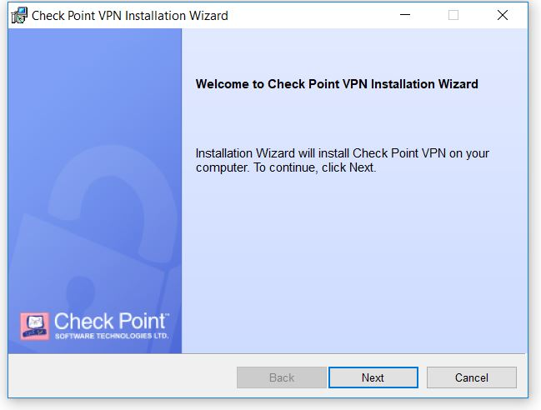
The Check Point VPN installation should begin. Click on Next

Step 4:
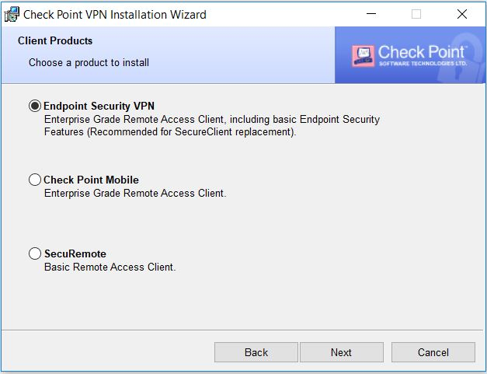
Ensure the Endpoint Security VPN radio button is the chosen option. Click Next.

Step 5:
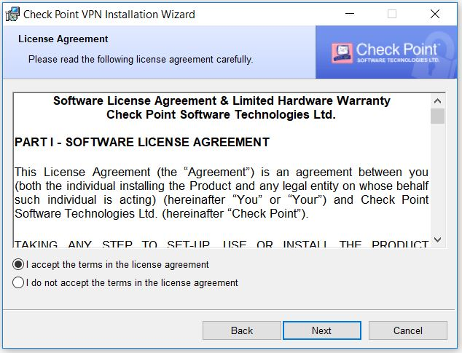
Ensure the first radio button is chosen. Click Next.

Step 6:
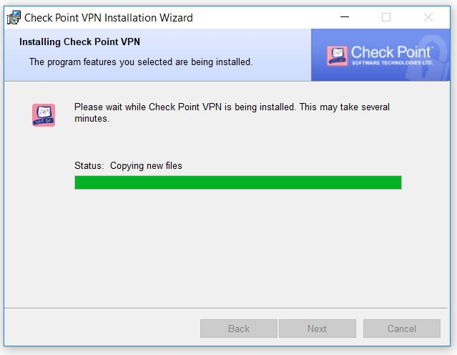
The software will begin to install and after a moment or two it should complete. When done the Next button will become available again and turn black. Click Next.

Step 7:
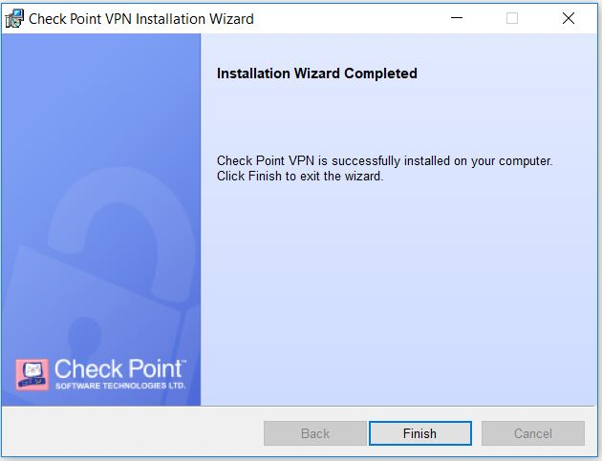
After Clicking Next you should see this screen. Click Finish to complete install.

Step 8:
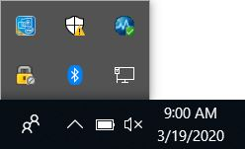
After the software installs you can find it on the Taskbar in the lower right hand corner down by the clock and date. Click on the up arrow and double click on the padlock icon.

Step 9:
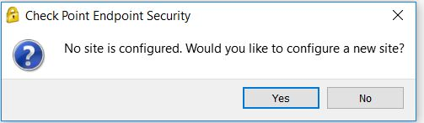
After you double click on the pad for the first time you’ll be presented with the site configuration window. Click Yes.
*** Steps 9 to 16 only needs to be done on first setup or on a reinstall. When connecting any time after you’ll be brought from Step 8 directly to Step 17 ****
Step 10:
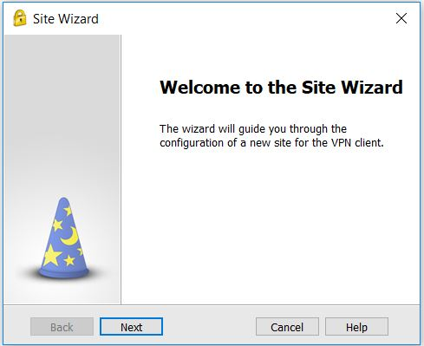
Click Next on the Welcome page.
Step 11:
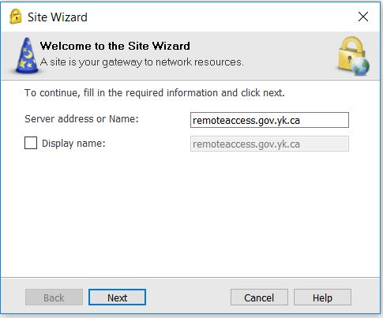
In the Server address or Name: field type in “remoteaccess.gov.yk.ca” (without quotes). Click Next

Step 12:
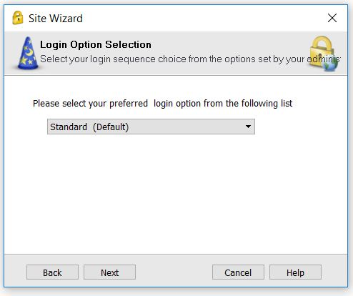
Leave Standard (Default) as the option and click Next

Step 14:
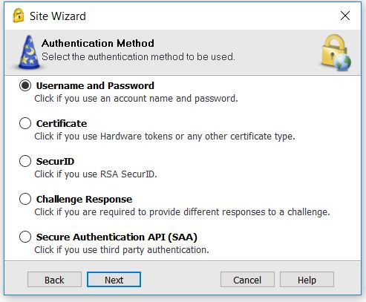
Ensure the Username and Password radio button is chosen. Click Next.

Step 15:
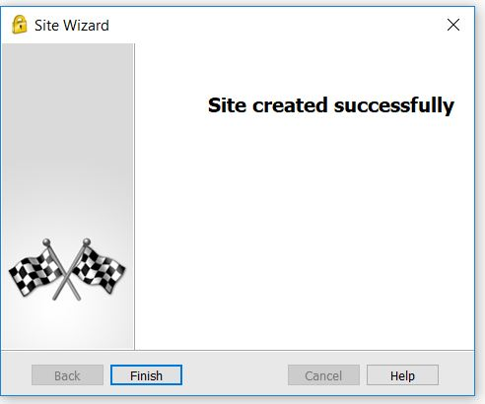
If you see this page the site has created successfully. Click Finish.

Step 16:
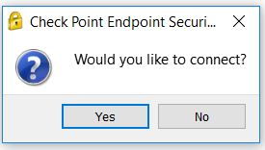
After clicking Finish in the previous you should be prompted to connect. Click Yes.

Step 17:
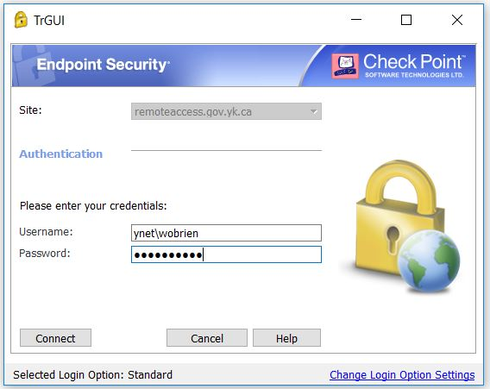
Enter your credentials ensuring that in the username: field it has the format ynet\Your Username. In password: field put in the password you use to connect to your work computer. Click on Connect.

Step 18:
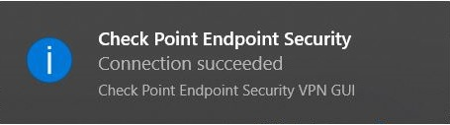
On a successful connection you should see the above message pop up.
Section 2: Connecting to your YG Computer
Part 1: Done at your YG computer
Step 1:
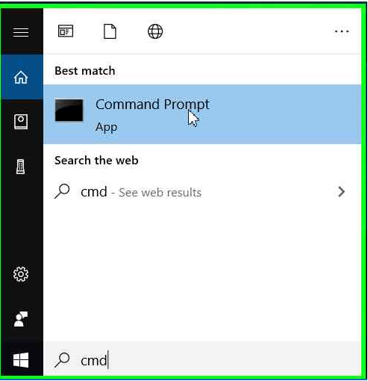
In the Taskbar search bar type cmd. Click on the Command Prompt app.
Step 2:
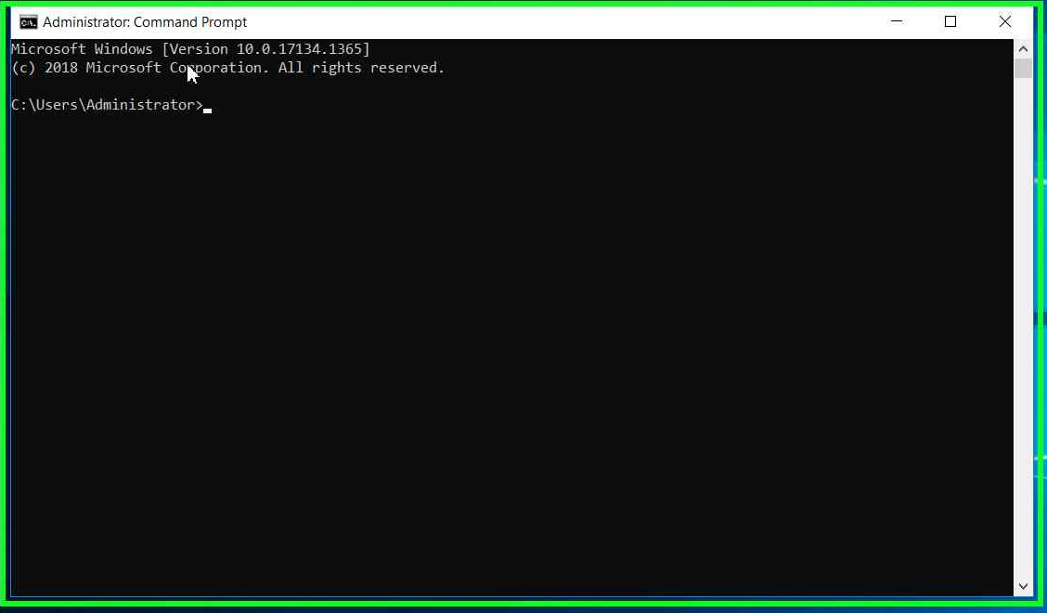
The Command Prompt app will open and display a window like the above. Just after the > there is a blinking line aka the cursor.
Step 3:
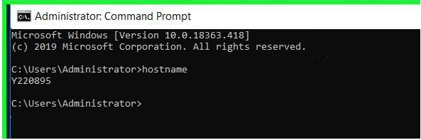
At the blinking cursor type the word hostname and the hit the Enter key on your keyboard. It should return the name of your YG computer. In this example the name of the computer is Y220895. You’ll need this name to use with the rdp or Remote Desktop Connection software on your personal computer.
Step 4:
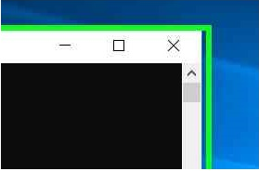
To exit from the Command Prompt app click the X in the upper right corner.

Part 2: Done on your Personal computer
Step 1:
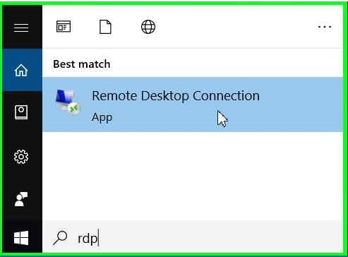
(A)
(D)
(C)
(B)

Click on the (A) Start button to bring up the Start Menu. Click on the (B) magnifying glass. Type (C) rdp in the search field and click on (D) Remote Desktop Connection. If rdp doesn’t bring up the app try typing Remote Desktop Connection or mstsc instead.

Step 2:
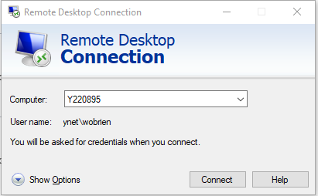
When Connection window appears click on Show Options to expand it.

Step 3:
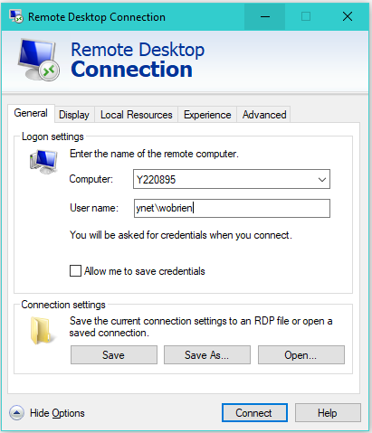
In the Computer: field type in the name of your YG computer. In the User name: field type in your username. Click Connect.

Step 3a: - *** This is an optional step saves you having to type rdp each time***
If you wish before you hit connect in Step 3 click on Save As… and save a shortcut on the desktop.
Step 3a: - *** This is an optional step saves you having to type rdp each time***
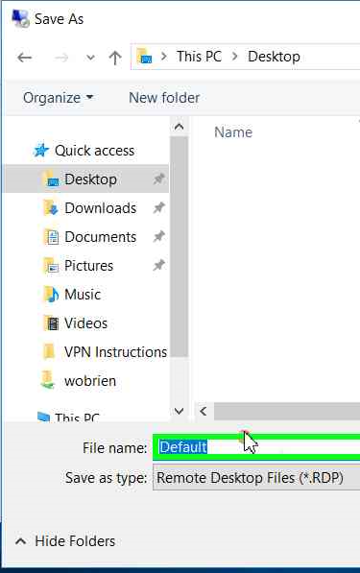
In the file name: change the name if you wish and click on the Desktop folder, click Save (not shown in example)

Step 3a: - *** This is an optional step saves you having to type rdp each time***
In the example below it was renamed to My Work Computer.


Step 4:
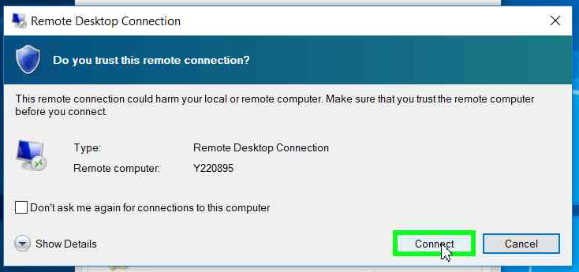
You’ll be prompted with a Trust window, click on Connect.

Step 5:
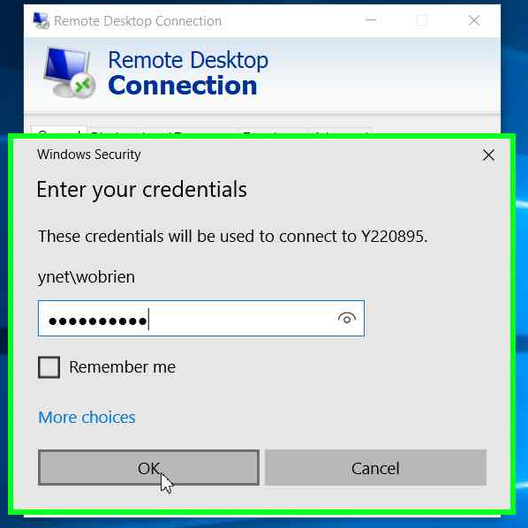
You’ll then be prompted to enter your password for your user acc on your YG computer. Click OK. The rdp connection will begin to load allowing access to your YG computer.

Step 6:
When the rdp loads it usually will expand to Full Screen size, to differentiate between your own personal device and your YG machine look for the menu bar as shown above. To minimize the screen click the ‘-‘ to make it sit as a window on your own screen click the 2 squares in the middle, for a quick exit click the ‘X’
Step 7:
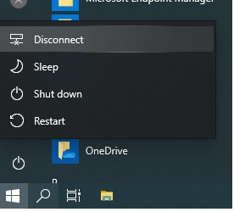
Click on the Windows button, right click on the Power Button then on Disconnect. This will leave the machine ready to be connected the next time.

Step 8:
You can disconnect from the VPN connection by right clicking the padlock icon on the system tray by the Date and Time and clicking on Disconnect. Access it from the up arrow.

